Dedicated to finding Vauter(s), Vawter(s), Vaughter(s)
Newsletter
March 2017 Volume 41 No 1
Reunion Dates:
San Antonio Texas July 13-16, 2017
Central Indiana July 2018
Kansas July 2019 and Virginia 2020

Website: www.vawterfamily.org
Officers
President Darren Welch, 402 N Galeston Ave, Indianapolis, IN 46229
Phone 317-899-1992 email: Darren.welch@cnoinc.com
Vice President Robert L. Vawter, 3773 Piper Bay Ln, Lakeland, TN 38002
vawter.bob@gmail.com
Treasurer Jordan M. Johnston…2450 Bear Creek Road
Pipe Creek, TX 78063 Phone 623-242-9296 email Jordan@bearcreekindustries.com
Asst. Treasurer Phil Vaughter…1103 Newport, Austin, TX 78753
Phone…512-836-3105 email PRV37@aol.com
Secretary Michelle Alexander, 489 Nannie Neal Rd, Hardin, KY 42048 email mrax3@juno.com
Archivist Beth Melton, 3809 Junker, Rosenberg, TX 77471
Phone 281-232-7972 email - emeltonea@aol.com
Newsletter & Georgene Jurgensen…8408 Mohican Ave
Genealogist Brooksville, FL 34613
Phone…816-591-0251 email gfjurgensen@gmail.com
Website & Patricia Renton…2372 Bear Creek Rd, Pipe Creek, TX 78063
Newsletter Phone…830-510-4625 email pvrenton@gmail.com

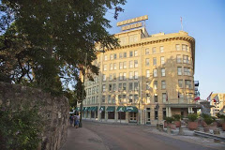
The Crockett Hotel
Address: 320 Bonham, San Antonio, TX 78205
Phone:(210) 225-6500
www.crocketthotel.com

Streamlined rooms and suites include free Wi-Fi, flat-screen TVs and coffeemakers. Minifridges are available for a surcharge. Some rooms feature fort views.
Amenities include free continental breakfast, an outdoor pool, paved gardens with a fountain, and a bar. The Crockett is a beautiful, old hotel which has been renovated very nicely, but has kept its old look and feel. The Atrium and guest rooms are beautiful, the Alamo and Riverwalk are just across the street, and River Center is located right next door as well. Additionally, there are guided river, bus, and bike tours right off the doorstep of the hotel.

Prices for the reunion are as follows: Cozy Queen $120 - Standard Queen/King $130 - Double/Double $140 Parking an additional $24 per day, handicap no charge

To get the special rates either call or go on line. Use this Code: 0717VVV

www.crocketthotel.com. Enter the Group Code and the travel dates
Reservations: (800)292-1050, give the code for discount rate

In Remembrance

Archie Andrew Boney, 94, of Clovis, died January 26, 2017, at the Retirement Ranch in Clovis. A graveside service was held on Friday, January 27, 2017, 2:00 pm, at Grady Cemetery, Grady, Curry County, New Mexico, with Doug Brooks officiating.
Archie Boney was born at home on October 1, 1922, near Bellview, Curry County, New Mexico, to L. M. and Malissia (Bryant) Boney. On May 21, 1950, he married Aline Vaughter in Clovis, NM. They were married for 59 years. He was an electrical contractor and farmer. He operated A. Boney Electric and farmed east of Clovis. After retirement Aline and Archie helped the Texas Baptist Men build churches in many communities in Texas, New Mexico and other states. He was a pilot and enjoyed flying for many years. Archie served in the U.S. Army from 1942 to 1945 in the south pacific during World War II. The last several of years he resided at Retirement Ranch in Clovis.
Survivors include two sons, Mark (Dawn) Boney of Lubbock, TX, Kim (Treca) Boney of Clovis, NM.; five grandchildren and eighteen great grandchildren.
He is preceded in death by his parents, L. M. and Malissia Boney; one sister, Mildred; and four brothers, Tom, Earl, Marshall, and Elmer, his wife Aline and one son, Gary.

Richard E. Vawter, age 64 of Merrillville/Crown Point, IN passed away on Monday, January 23, 2017. Richard was a local attorney for many years in Merrillville. Rick is survived by his wife, Wanda and children Ryan Vawter of Crown Point and Marissa Vawter-Lee ( Lynn Lee) of Cincinnati, OH. Additional survivors include his mother, Betty of Sheridan, IN; Sister, Pamela Hintalla (William) of Riverview, MI and brothers Phil (Tina) of Sheridan and Keith(Janet) of Noblesville, IN. Sister-in-law, Brenda S. Lycan of Rockville, IN and brother-in-law Frank A. Freeman(Pam) of Ft. Wayne, IN. Rick was devoted to his family and friends but especially to his two children Ryan and Marissa and his dog, Rocky. He was an avid lover of sports, especially the Chicago Bulls. In Rick's honor we request that you go out and do something fun, travel the world (something he loved to do) but above all-- love and hug your family! Prior to attending law school, Rick worked at US Steel, Gary Works for 7 years. Richard was a Member of the Board for IN-PACT for over 25 years.

Page 2
Benjamin Vauter of Ripley, Indiana

The complete will of Benjamin Vawter was found in the Ripley County Historical society. This Benjamin’s line is : Aaron 5, Benjamin 4, Richard 3, Unknown 2, Bartholomew 1.

Be it Known that I, Benjamin Vauter of the county Ripley in the State of Indiana do hereby publish this My Last Will and Testament hereby revokeng all former wills by me at any time theretofore. Made to Wit, First I will at my death that After I am dead I be decently Burried and All My Just Debts be paid.
2 Second, I will to my Beloved Wife Francis Vauter all my Estate boath Real and Personal to have and to hold at her control full and Peacible possession during her life and at her death dispose of as She May Think Proper, Except one Thousand Dollars.Third, 3, I Will to Malind, Francis and Ellsberry
And I hereby Appoint my beloved Wife Francis Vauter Executrise of this my Last Will and Testament in presence of James McGee and Frances Oneal in Witness whereof I Benjamin Vauter the testator have hereunto Set my hand and Seal this Eighth Day of September Eighteen Hundred And Sixty nine, 1869,
Benjamin Vauter, Seal
Signed and sealed and Acknowleged by Benjamin Vauter as his last will and Testament in the presence of us who have hereunto subscribe our names and witness thereto in the presence of the said Testator and in the presence of each other This 8th day of September 1869. James McGee and F. C. Oneal

Will and Testament of Benjamin Vauter, Witness James McGee, filed 27th day of Dec 1880, by James W. Pate, Clerk. Will Record page 168, Order Book No. 8 page 403, Fee book No H1, page 164.

Benjamin Vawter b. 6 July 1806 Mercer Co., KY, d. 14 December 1880 Ripley Co., IN m. 22 March 1836 Jefferson Co., IN to Frances Means; b. 2 Aug. 1815 Jessamine Co., KY, d. 25 July 1912, Ripley Co., IN.
Indiana State Library Genealogy Division "U-V-W-X-Y-Z" Indiana Marriages Through 1850 “Vawter” http://ww.statelib.lib.in.us
Bride or Groom Spouse County Date Remarks
Benjamin VAWTER Frances MEANS Jefferson 22 Mar 1836
1850 Census of Ripley Co., IN M432, roll 169, Shelby Township, p. 324B family - dwelling 27/28
Benjamin Vawter 44 M Farmer $1400 Ky.
Frances Vawter 35 F Ky.
Benj O. Mastin 19 m Farmer Ky.
Lutitia Mastin 7 f Ia. "
Brown Township Cemetery Records Ripley County, Indiana. Ripley County Historical Society, Versailles, IN, 1984. p. 21 (inscriptions from the Baptist Cemetery at Cross Plains, Indiana.)
"Vauter, Benjamin born in Mercer Co., Ky. died Dec. 14, 1880 aged 74 yrs. 5mos. & 8 days
Vauter, Frances born in Jessamine Co., Ky. Aug. 2 1815, died July 25, 1912."
( JM note: This cemetery is about 5 or 10 miles from the cemetery where William and Matilda Vauter are buried. No other Vauters are buried here.)

Marriage of Milton M Vawter and Laura E. Shadday, Ripley County Indiana

License issued to Milton M. Vawter and Laura E. Shadday on 8 September 1892.

State of Indiana, Ripley County: This certifies that I joined in Marriage as Husband and Wife Milton M. Vawter and Laura E. Shaddy on the 11th day of September 1892. A. B. Houge, V D M

Marriage Return. Milton M. Vawter of North Madison, Ind. Age next birthday 25, occupation artist, Father Thomas Vawters, Mother Anna Gill to Laura E. Shaddy of Rexville, Ind age next birthday 19, born at Rexville, Ind. Father Erasley Shaddy Mother Olive Riley. Place of Rexville, Ind filed Sept 11th , 1892 by A. B. Houge
Page 3
A Brief History Of Greenville Community
(Monroe County, West Virginia)
by George W. Vawter

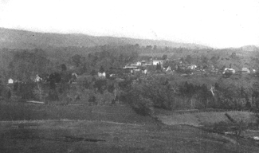 | It appears that about the year 1770, Valentine Cook and his brother Jacob came to the farm now owned by J. R. Johnson, one fourth mile west of Greenville. With the help of other families whose names seem to have included Miller, Hann, Campbell, Ellison, Bradshaw, Henderson, Thompson, and Bland, they constructed a fort known as Cook's Fort.
Among the many skirmishes the settlers had with the Indians, those of Valentine Cook are best known. At one time he was captured by the Indians, taken up on Indian Draft, and there forced to trade his good rifle with the Indians for a very poor one, after which he was permitted to return home unharmed. Jacob Cook, who a few years ago married the widowed mother of Frank and Luther Maddy of Greenville, is a direct descendant of Valentine Cook.
Jacob Mann, the great grandfather of I. N. Ballard and S. M. Mann of Greenville, was born in Albemarle County, Virginia, near where the city of Charlottesville now stands. When about thirty years of age he moved to this community, and assisted in the construction of Cook's Fort. He was one of the most outstanding Indian fighters of the community. On one occasion the Indians killed an entire family who lived, in the vicinity. Jacob Mann in command of five others started in pursuit of the Indians. After following them for five days they came upon them at the close of day, camped on the banks of the Ohio River. It was decided, after holding a council of war, to wait until morning before attacking the Indians who were seven in number.
Jacob Mann's instructions to his men were that each one should select his Indian so that no two would shoot at the same one. At the first fire six Indians fell dead. The seventh dropped his gun and jumped into the Ohio River. Jacob Mann, being a great swimmer and possessed of unusual physical strength, leaped in after him. Catching the Indian about midway of the river, he killed him with his hunting knife.
At another time the food supply at the fort became exhausted and Jacob Mann started up Cook's Run across into the Flatwoods on a deer hunt. He succeeded in getting a deer and had begun his return with the carcass on his back, when encountered by Indians. He started on the run for the fort. But when about three-fourths of a mile from the fort, he saw it was either throw away the venison, and let those at the fort suffer, or be captured himself, as the Indians were consistently gaining on him. About that time he saw a depression in the ground, which turned out to be a small cave. Throwing the meat into the hole, he immediately crawled in after it. His dog followed, and hearing the bark of the dog, Jacob Mann held its mouth shut tight, while the Indiana prowled around so close at times that the muzzles of their long rifles brushed the weeds about the mouth of the cave. After a time the Indians departed, and he was successful in reaching the fort with the precious venison before daylight.
John Ellison, grandfather of J. Z. Ellison, who now lives on Hans Creek, was one of the men who lived in Cook's Fort at times for a number of years. While living there he cleared out about two acres of land near where Mr. J. Z. Ellison now lives. This land he planted in corn and would walk from the fort three miles away over Ellison's Ridge to cultivate his crop. At a later date he built a log house just at the forks of the road where it turns to go to Dry Pond.
A family by the name of Meeks lived near the mouth of Indian Creek some ten miles west of this house built by Mr. Ellison. They were attacked by Indians and the entire family with the exception of Mr. Meeks
Page 4
were captured and carried away. The oldest and the youngest in the group Mr. Meek's mother and his baby were killed by the Indians. Mr. Meek's mother, who was a very large woman, had on a homespun dress at the time. This the chief of the Indians appropriated for his own personal costume. We are told that it reached about to his knees.
John EIlison was the nearest neighbor of the family, and a runner was immediately sent to notify him of the capture. Ellison in command of five men, three of them his sons and two others by the name of Paul, set out in pursuit of the Indians, whom they overtook on the Kanawha River. Mrs. Meeks seemed to realize that help was near. She quietly got her children together at a place as far removed from the Indians as possible. The rescuers fired into the six Indians and killed them all. Ellison afterward returned the Meeks family to their home.
Among the early settlers of the Greenville Community was a Mrs. Anne Maddy. Her husband who had been a soldier in the Revolutionary war was accidentally drowned in the Shenandoah River. Mrs. Maddy came with her children to Monroe County, and settled on the land now known as the Chas. Maddy farm, near the Saltpetre Caves. At this place she brought up her family. Being the owner of considerable property in Virginia, she was compelled at one time to go back to the state to dispose of her holdings there. She rode alone all the way on horseback through the mountains and wilderness country.
After transacting her business and receiving the money for her land, she started on her way home. She stopped over night in the Wilderness with a settler. During her stay there, she happened to disclose the fact that she had considerable funds with her. The settler suggested to her that she take a short cut across the mountain on her way home. In addition he offered to pilot her a part of the way. He took her to the top of a very high cliff, and told her that he wanted her money, that he intended to push her over the bluff and kill her. She told him that her money was sewed up in her clothes and that she would have to take off her dress to get it. She asked him to turn his back while she removed her dress. He turned his back facing the cliff, and she immediately pushed him over, killing him and saving her own life. Mrs. William Comer, Frank and Luther Maddy, all of Greenville, are direct descendants of this Mrs. Anne Maddy.
In 1798 Peter Larew, the grandfather of Peter and Lewis Larew who now live on Hans Creek, traded a farm that he owned in Augusta County, Virginia, to Priscilla Gould for the farm that his grandson, Peter Larew, now lives on. This farm has been in the Larew family for one hundred thirty years.
In the year 1808 Robert Shanklin moved to the farm where Newton Ellis now lives about one mile west of Greenville. The field in front of Ellis' home has been in corn for one hundred eighteen years in succession, and still grows a good crop. A little later William Shanklin, his brother, bought the three hundred thirty-three-acre farm on which Vetner Shanklin now lives. The taxes on this farm at that time amounted to only three dollars per year.
Homes and Public Buildings
The first house in Greenville was built for James Vawter, uncle of the writer, and stood where Frank Maddy now lives. This home was built by John Houchins in 1844. The next house was a store constructed for the use of my father and uncle, James Vawter, and stood just about on the location of the present J. F. Maddy's store. The third house was the Logan-Shanklin home, in which he kept a hotel. There was a store house built about this date on the corner where R. H. Arnott's store now stands, in which Baldwin Ballard and his brother John carried on a general mercantile business.
What is now Greenville was known at that time as Centerville. In the course of a lot sale in the town, John Houchins bought two lots, one opposite the Presbyterian Church, where he constructed a building, in which he ran a carding machine by horse-power.
The Methodist Parsonage was built at a very early date. About the same time a dwelling house was put up by Jim Lawrence, in which Dr. Shannon Butt lived. Dr. Butt was the father of Dr. Henry Butt who had for years the largest country practice that any physician ever had in Monroe County. Not far from this time Anderson McNeer put up a tobacco factory, and his brother John a tannery.
Education
The first school in the vicinity of Greenville was taught by William Shanklin to whom reference was made above. It was located in a house about half way between his own and that of John C. Ballard. The first school house in Greenville stood on the point of the ridge, below the Methodist Church. It had but one window, and that a small one containing eight panes of glass, size 8 by 10 inches. The earliest teacher mentioned was Henderson Ellis who certainly was on the job in 1857.
Page 5
Early Churches
The first church established in the neighborhood of Greenville was that of the Primitive Baptist Denomination. It bore the name of Indian Creek Church, and was built one hundred thirty-four years ago. The present building is the third on the same site. The earliest Methodist Church was called Mt. Bethel which stood on the point just below the present church. The record shows that on September 10, 1845, the following trustees were elected: Richard Thomas, Richard McNeer, William Arnott, John H. Vawter, Armisted Ross, Henry Taylor, and Sylvester Upton. The Presbyterian Church was organized in June 1854. One year later the Rev. M. H. Bittinger became the pastor of this church to which he gave an active service of fifty years. He was known and loved by all the people of the community regardless of of denominational preference. The first elders were William Hinchman, Robert Young, Richard Thomas, and Richard Shanklin.
Tom Miller, who had been a captain in the war of 1812, came to Greenville in April 1851. He was the father of A. P. Miller, who made a most unusual and distinguished record in the Civil War. He fought in Stonewall Jackson's Brigade and took part in every engagement but one. He missed that battle only because he was severely wounded at the time. He was wounded three times and on one occasion lay on the battle field for three days and nights without food or water. Despite his wounds he lived to the age of 93, and died in Greenville in the year 1924.
No attempt has been made to give a history of the community during the Civil War. Suffice it to say that some of the men who fought through the War never got tired of talking about it. John Maddy had put up just after the Civil War a pair of cattle scales, which are still being used today.
Greenville now has two churches, one bank, doing a good business, three stores, two garages, one blacksmith shop, one large flour mill, one hotel, and an excellent high school

VIRGINIA DUELLING. During the war of 1812 there were a number of duels among army officers. Col. James Bankhead, afterward General, grandfather of Gen. J. B. Macruder, and Buckner fought in Vauter's church yard, in Essex county, but after firing once they were reconciled.

The Roanoke Times, Volume 10, Number 101, 15 January 1892
Miss Josephine Vauter, who has been visiting Miss Maggie Ott, returned to her home near Charlottesvllle yesterday.
Does anyone know the connection of this family to the Vawter lineage? Always fun to add a new cousin. GJ

HISTORY OF HOMŒOPATHY
AND ITS INSTITUTIONS IN AMERICA
By William Harvey King, M. D., LL. D. Presented by Sylvain Cazalet CHAPTER VI THE HOMŒOPATHIC MEDICAL PROFESSION
WALTER ELIOTT FRUIT, Chicago, Illinois, was born in Edwardsville, Madison county, Illinois, November 9, 1862, son of Jefferson and Elizabeth Vawter Fruit. Originally Scotch-Irish, the family has been American since some time previous to 1750. His literary education was begun in the country schools of Illinois and continued through the normal school at Valparaiso, Indiana, and Lincoln University. Illinois. In 1890 he graduated from the Hahnemann Medical College of Chicago. Since graduation he has been connected with the following hospitals and colleges : National Medical College, Chicago, professor of diseases of children, 1890-93 ; Hering Medical College, Chicago, the same, 1893-97 ; Chicago Homœopathic College, the same, 1897-1904 ; Hahnemann Medical College, Chicago, the same, at the present time ; Chicago Hahnemann, professor of pediatrics ; Chicago Homœopathic Hospital, professor of pediatrics ; Mitchell Training School for Nurses, lecturer on pediatrics. Dr. Fruit married, in 1893, Ellen Elizabeth Crossman. They have one son, Julian Eliott Fruit.

Page 6

HISTORY OF PECKS AND HANBYS IN ROCKWALL COUNTY, TEXAS
*Denotes Those Who are Buried in the Kyser-Peck Cemetery
Following the Civil War and the loss of the Peck's plantation in Giles County, Virginia, the family of JOSEPH ADDISON PECK* began a migration to the state of Texas. In the spring of 1877, Joseph Peck and his wife, ELLENORA BAKER PECK* moved with five of their six offspring to the New Hope community in Dallas County, Texas. The children who moved with them were: JOSEPH VAWTER PECK*, aged 22; EMMA CANNON PECK*, aged 20; WALTER BEVERLY PECK*, aged 16; HENRY AUGUSTUS PECK*, aged 14; and ROBERT EDWARD LEE PECK, aged 13. Their oldest daughter, ELIZABETH JOSEPHINE PECK*, had married PETER SHARP HANBY* on January 9, 1877. Elizabeth and Peter did not move to Texas until November of 1877 after the birth of their first child, WALTER PECK HANBY*. When Peter and Elizabeth came to Texas, his brother, JOHN WALKER PECK* moved with them. John had been romantically involved with Emma Cannon Peck before she left Virginia and they were married in Texas on June 20, 1878.

In 1881, the Pecks and the Hanbys purchased land in Rockwall County, Texas, near Heath. Houses were built, orchards and gardens were planted, and wells were dug for water and walled with brick. In the two Hanby families, children were being born at regular intervals. Between 1877 and 1891, Peter and Elizabeth produced nine children in all: WALTER PECK HANBY*, LEE THOMAS HANBY*, NORA (NONA) McCHESNEY HANBY, AUGUSTA LEIGH HANBY BOYD*, ALMA VAWTER HANBY*, CARL FREDERIC, CLINARD JOSEPH HANBY, HENRY LLOYD HANBY, and JEAN KATHLEEN HANBY*. When Jean Kathleen was only three weeks old, Peter Sharp Hanby died at the age of 43 leaving Elizabeth a widow at 36 with nine children.

John and Emma Hanby were also very productive during this time. Their ten children were born between 1879 and 1898 including: FRANCIS HENRY HANBY, JULIA LLOYD HANBY JONES, MARY GRAY [GAY] HANBY, JOSEPH ALFRED [BON] HANBY, BEVERLY BANE [DIMP] HANBY, JOHN WALTER HANBY, JR.*, ROBERTA LEE HANBY*, WINNIFRED DAVIS HANBY, HUGH LAWRENCE HANBY GUGGENHEIM, and VICTOR RAYMOND HANBY.

Two of Joseph and Ellen's sons, Walter Beverly and Henry Augustus remained single all of their lives. Joseph Vawter married LAURA FRANKLIN, bought land near his parents, and built a house. Joe and Laura had four children: an infant who died at three weeks*, JEAN VAWTER PECK*, ELIZABETH LLOYD PECK*, and EMMA LEIGH PECK. The youngest son, Robert Edward Lee Peck married RUTH BURCH on December 12, 1906. They were the parents of three children: ELISE, ROBERT, and HENRY.

Page 7

How did you meet your spouse?
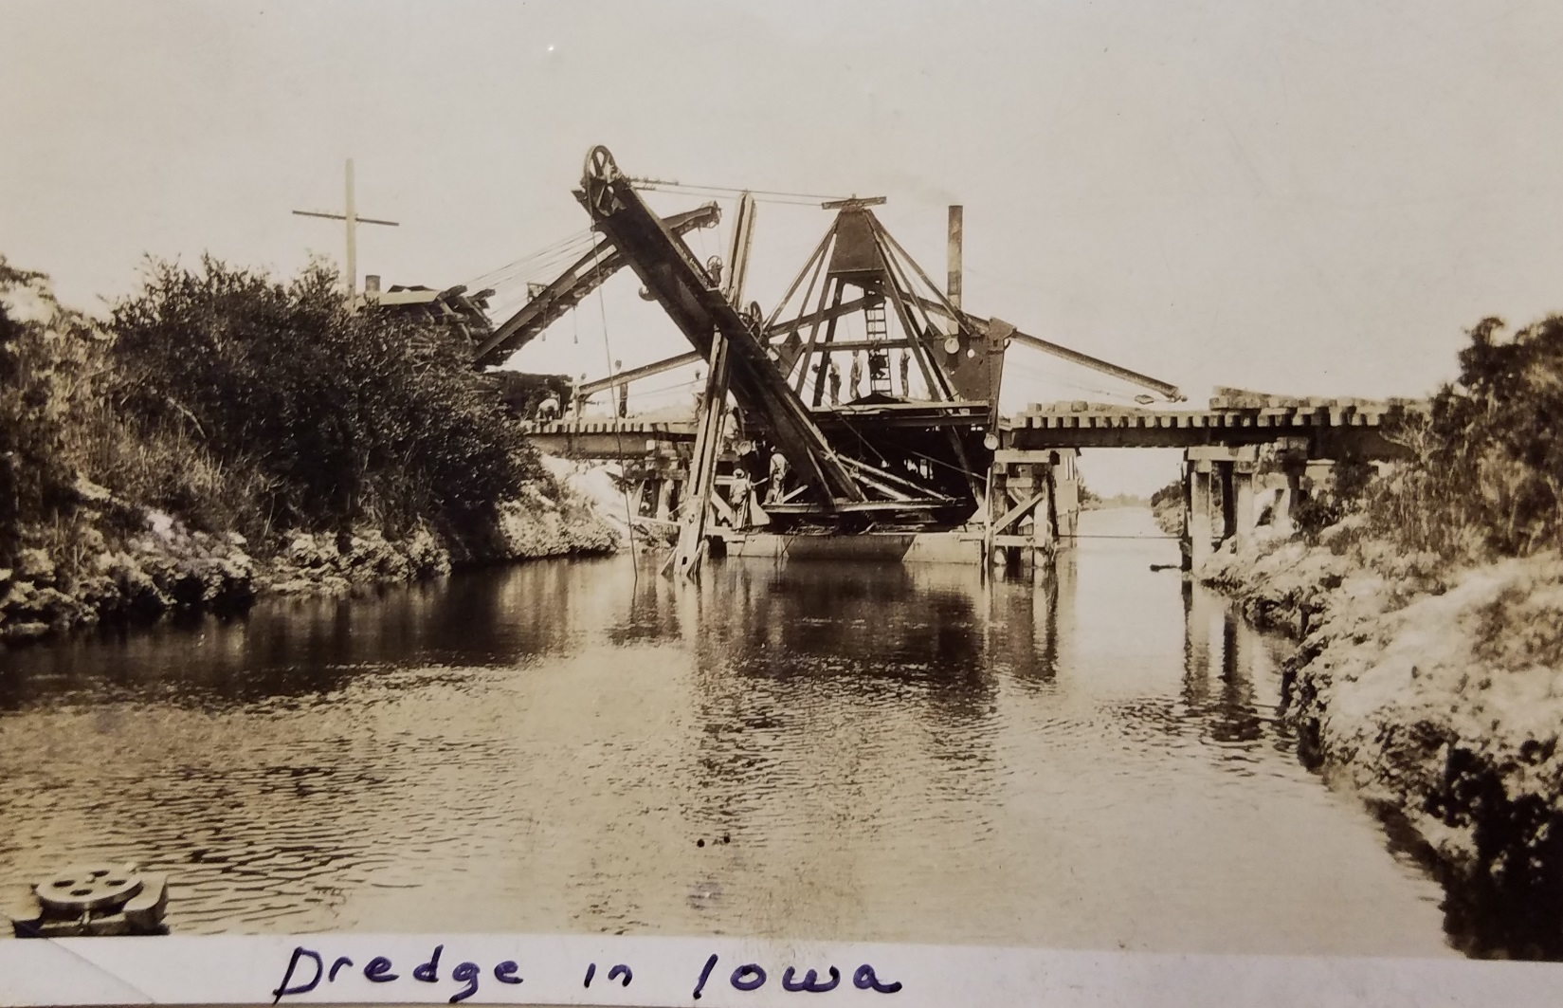
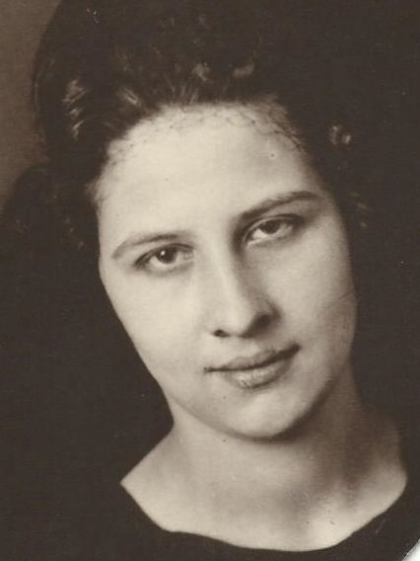
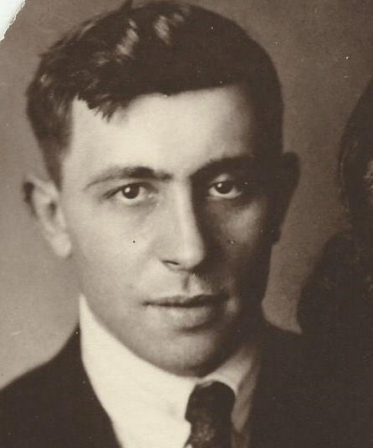
One of the many interesting things about genealogy is not dates and names but the true story of how people actually met. Travel was difficult, people of marrying age were often limited but many a long term and happy reunion was forged. My story is about my grandfather, George Dewey Dunn, son of John Dunn and Ada Ann Vawter who was born and raised in Indiana. How did he get to Iowa and meet and marry in 1921, a shy German girl, Martha Waterstradt, who lost her father as an infant and her mother as a young teenager? She and her sister lived with an aunt and uncle in Benton County, Iowa. She worked at a “road house” cooking and making pies to earn money. Something that the family did not fully approve. The family stories were that George operated a dredge in Iowa, but where and why. With a dredge photo given by Ada’s granddaughter, Norma Jean Peed, and some internet search, it seems the meeting of these 2 people is finally solved. Cedar Rapids, Iowa located in Benton County, brought a single young man who worked hard to find a shy German girl working in a restaurant where he likely chose to eat a meal. And throughout her life, her baking skills were acclaimed. After all………….the way to a man’s heart is through his stomach.
Cedar Rapids, Gazette, Oct 17, 2016
For centuries, the sandbars in the Cedar River drifted and flowed with the river current. Then, in the late 1800s, William King thought about how useful that sand would be in making plaster and cement. King, the son of David King, grew up on the west banks of the Cedar where David King had founded Kingston, later known as West Cedar Rapids.
In 1882, William King established a business near a spot where he had once fished at First Street and I Avenue NW. He sold coal and fuel for heating but needed to sell something else in the warmer months. He chose plaster and building materials.
Soon William King & Co.’s secondary enterprise became its primary business as King created and refined a plaster that was more convenient and less caustic than the lime and horsehair plaster then in use. The lime plaster’s major disadvantage for builders was that it took weeks to dry.

RIVER SAND
The formula for King’s plaster was a well-guarded secret. It was easier to use, required much less water to mix and dried considerably faster than lime plaster. It withstood frost and didn’t deteriorate over time. It didn’t conduct heat and was considerably stronger than lime plaster.
The main ingredient for King’s plaster was sand dredged from the Cedar River. King discovered the river sand was the perfect consistency for mixing plaster. He also bagged and sold the sand separately.
In 1902, King changed his company’s name to King’s Crown Plaster Co. By 1921, it was the largest plaster mixing mill in the state. The company’s dredges pumped 300 cubic yards of sand a day — a yard was about 1-1/2 tons — from the Cedar to make the plaster. The company also made 700 concrete blocks a day and sold brick, building stone, colored mortar and building finishing materials.
While King and other companies were dredging sand from the river, the city’s riverfront commission was struggling with limited funding to maintain and improve the riverbanks. In 1910, the commission decided to revive a temporary fee charged several years before for companies taking sand and ice from the river. The commission — looking at Waterloo’s sand-extraction fee that brought in $1,500 in 10 months — set Oct. 1, 1910, as the date it would begin collecting 5 cents per yard of sand. Eventually, those fees were turned over to the state conservation fund.

CONCRETE BUSINESS
When William King died on Oct. 21, 1929, the company’s vice president, J.W. Pichner, took over. When he died in 1935, King’s nephew, William C. Crawford, took over the company with Ira R. Brooks as his vice president.
As the ice went out of the river in the spring of 1950, two King’s Crown barges broke loose from the company’s dock and headed for the old Cedar River dam. One barge was totaled, but the other was pulled from the river and returned overland river to the dock. By 1951, King’s chief business was ready-mixed concrete made with sand from the Cedar. Its dredging operation kept the river open for boaters near Ellis Park. Sand bags for flooding came from King’s stockpile. The sand was used for other city purposes through the summer.
Page 9
The company had 20 trucks to mix the concrete in transit to construction sites, usually within a 30-mile radius. Crawford estimated that by 1951, the company had taken a couple of million tons of sand from the riverbed.
King’s last barge was built by Iowa Steel and Iron Works in 1963. The 30,000-pound vessel replaced a sand dredge that had been in use for 25 years. The river sand collection ended when that barge was pulled from the water.
In the 1970s, King’s merged with Builder’s Material, a masonry supply company. In 1978, that company was bought by C.P. Rhode.

LARIMER & SHAFER
Other sand dredges that plied the Cedar were operated by Larimer & Shafer Co. and Concrete Materials & Construction Co.
Robert I. Larimer’s father, Alexander, served in the Civil War as a member of the 54th Pennsylvania Regiment. After the war, he moved to Cedar Rapids and in October 1866 married Martha Listebarger. After farming for several years, he and Gustav A. Shaffer opened their sand and gravel company in 1905 at O Avenue and First Street West.
Within five years, they were able to build a new sandboat, shipping timbers to build it to the Fay Brothers Lumber Co. on First Street SE.
A 1909 newspaper story said that at 70 feet, the timbers were the longest ever shipped to Cedar Rapids.
Larimer & Shaffer’s steamer and big sand dredge cut a channel through a large sandbar to Kelsey’s Bend, near Covington, for the Cedar Rapids Motor Boat Club in 1911, keeping it open for the summer. It also eliminated several other sandbars, including one across from the Ellis Park island.

A RESCUE
In 1913, the sand barge and steamer took part in a rescue when Dr. William Finn found himself stuck on the dam with a boat motor that had stopped working. To keep from going over the dam, he held on to a cable that had been stretched across the river. Ed Sheftic of the west-side boat house came to his rescue and promptly found himself clinging to the cable when his engine also failed. Larimer & Shaffer’s steamer rescued the stranded pair and their boats.
Larimer & Shaffer began to move off the river in 1932 when the company landed a $40,000 contract for crushed rock from Benton County. Workers installed $90,000 worth of equipment in the company quarry adjoining the main line of the Rock Island Railroad.
By 1936, at the height of the Depression, Larimer & Shaffer was bankrupt and in receivership.
The third company to dredge the river was Concrete Construction Co., founded in 1908 by Harry D. Bellamy. Martin Marietta bought the company in 1959 and moved dredging operations off the river and onto a pond on its site. When the pond was depleted in 1997, Martin Marietta returned to the river, launching a barge near the company’s Otis Road SE facility.
Page 10

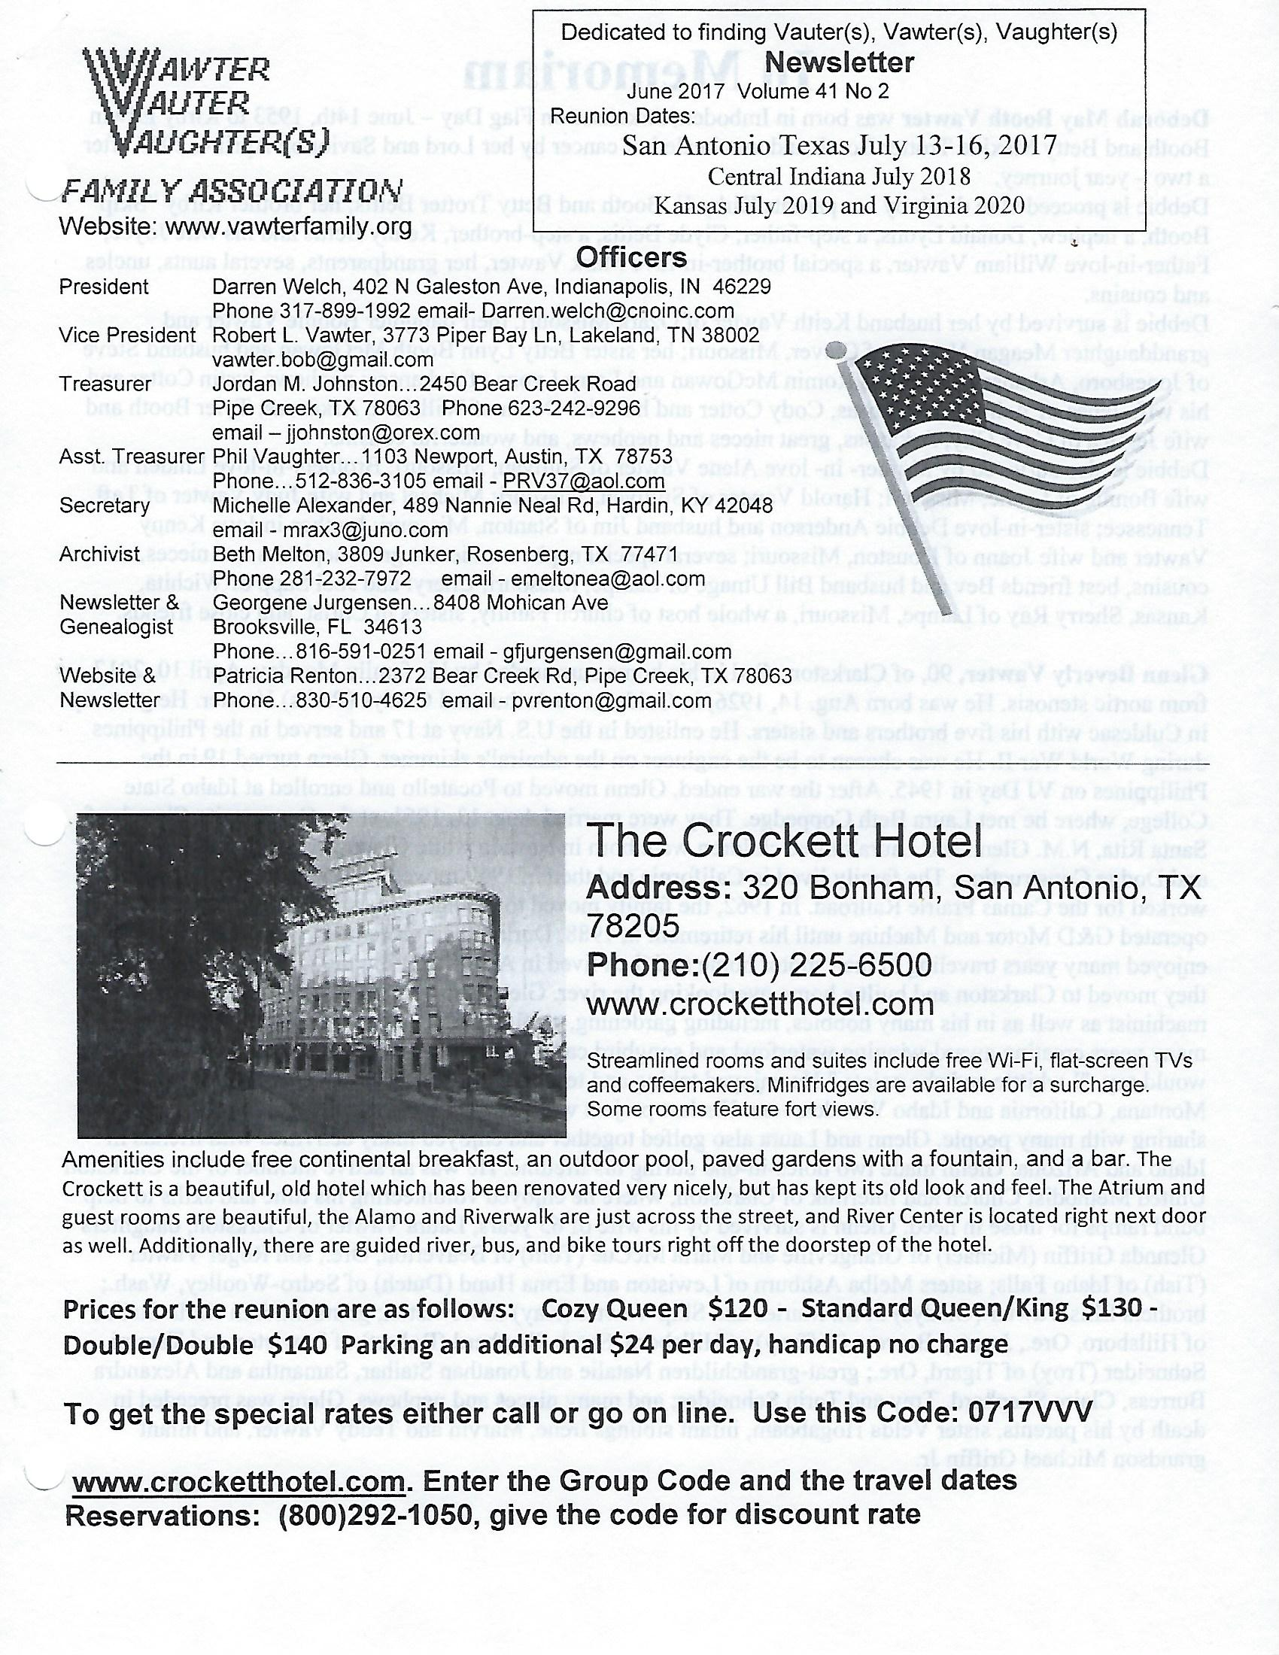
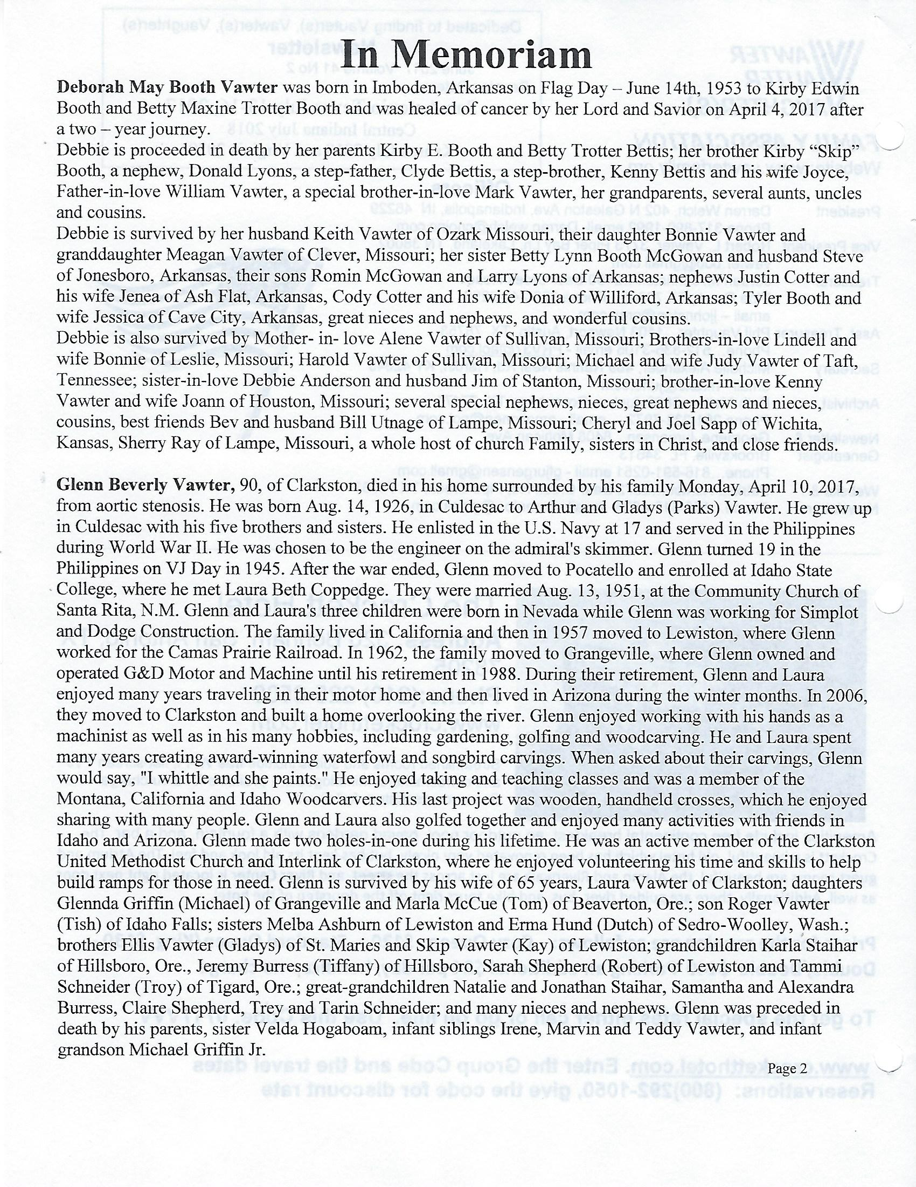

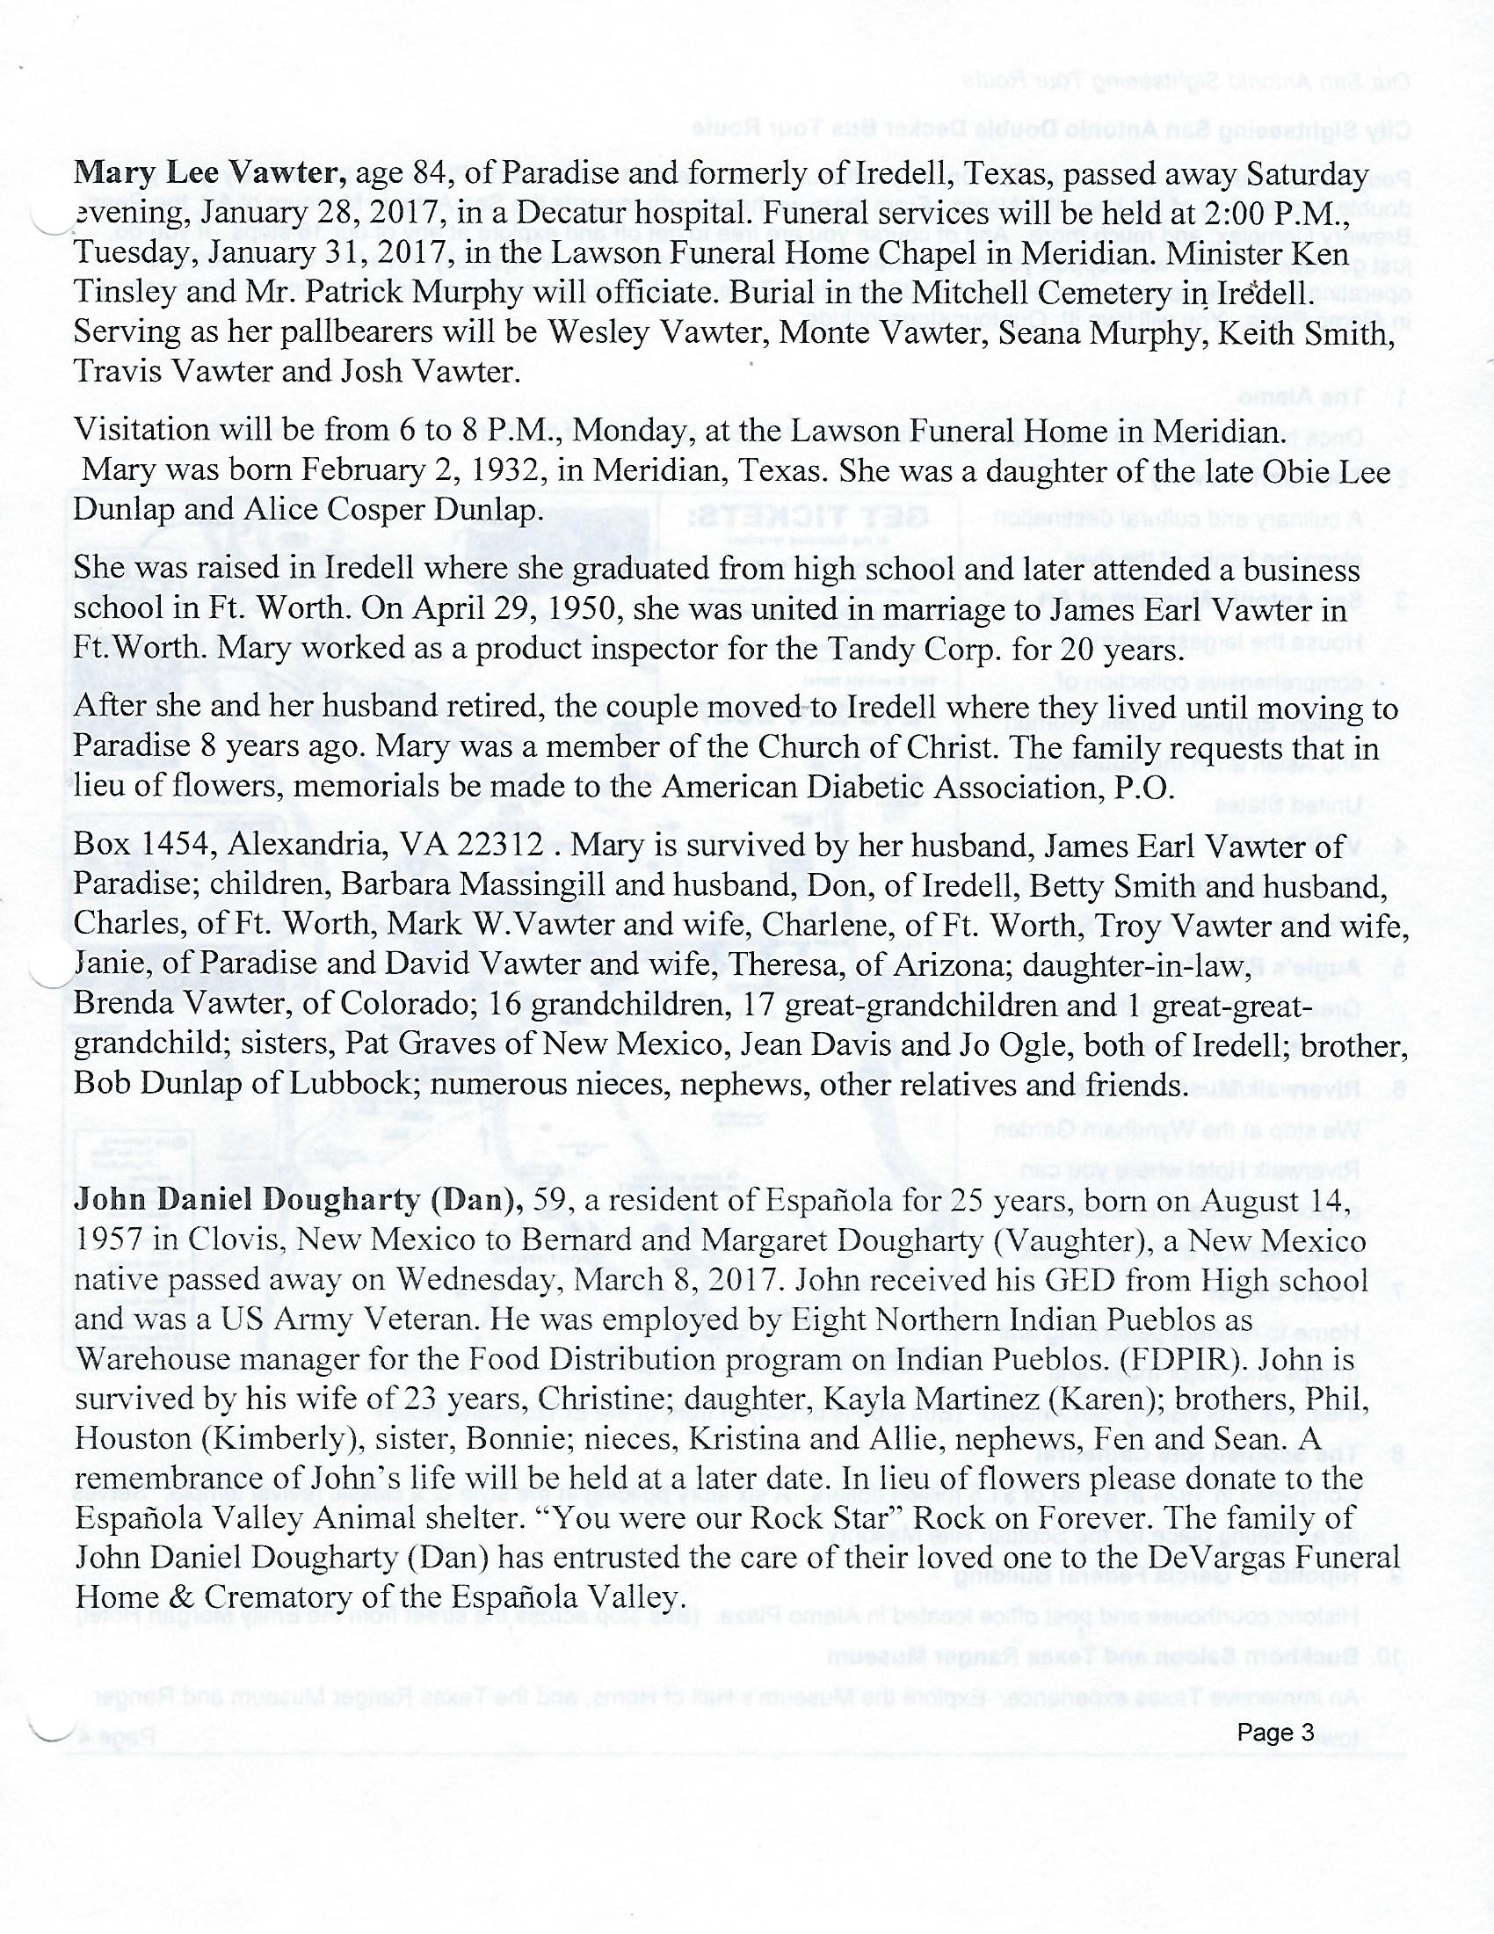

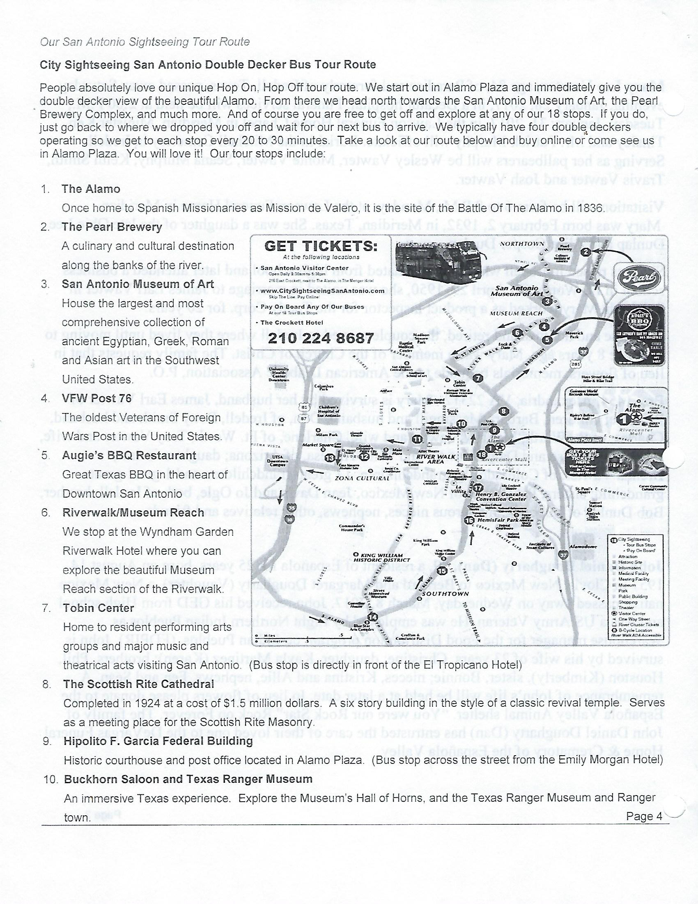

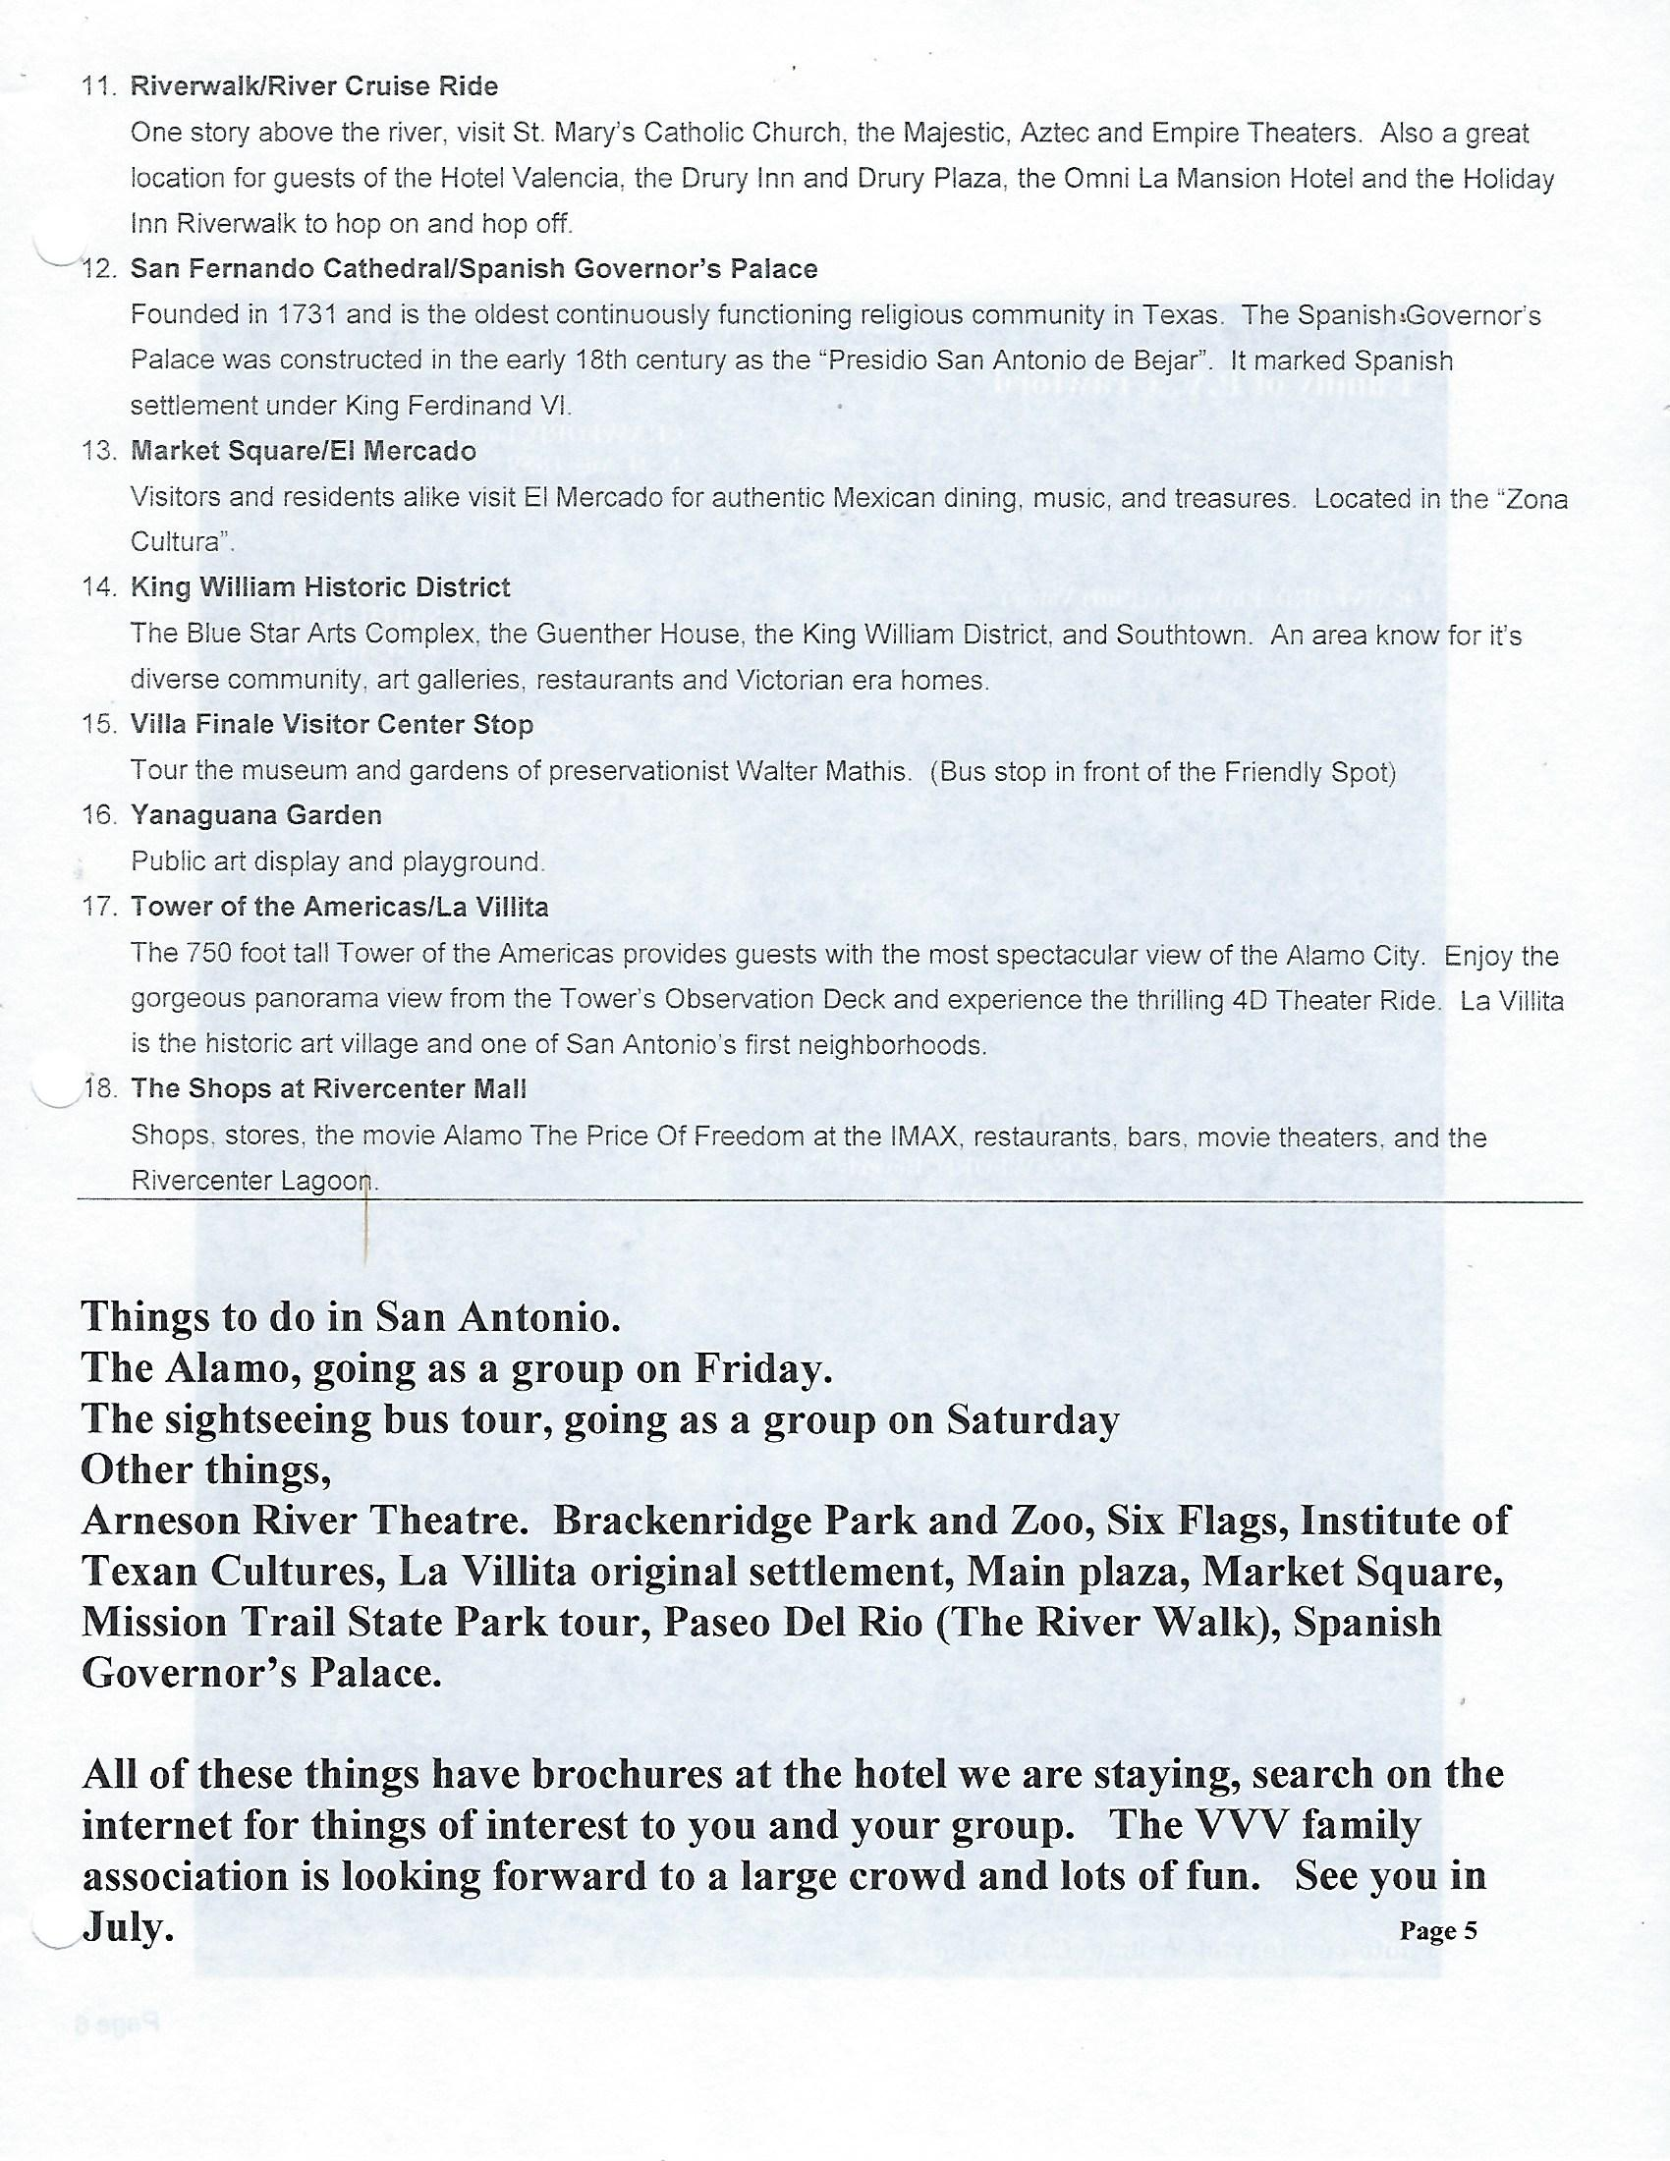

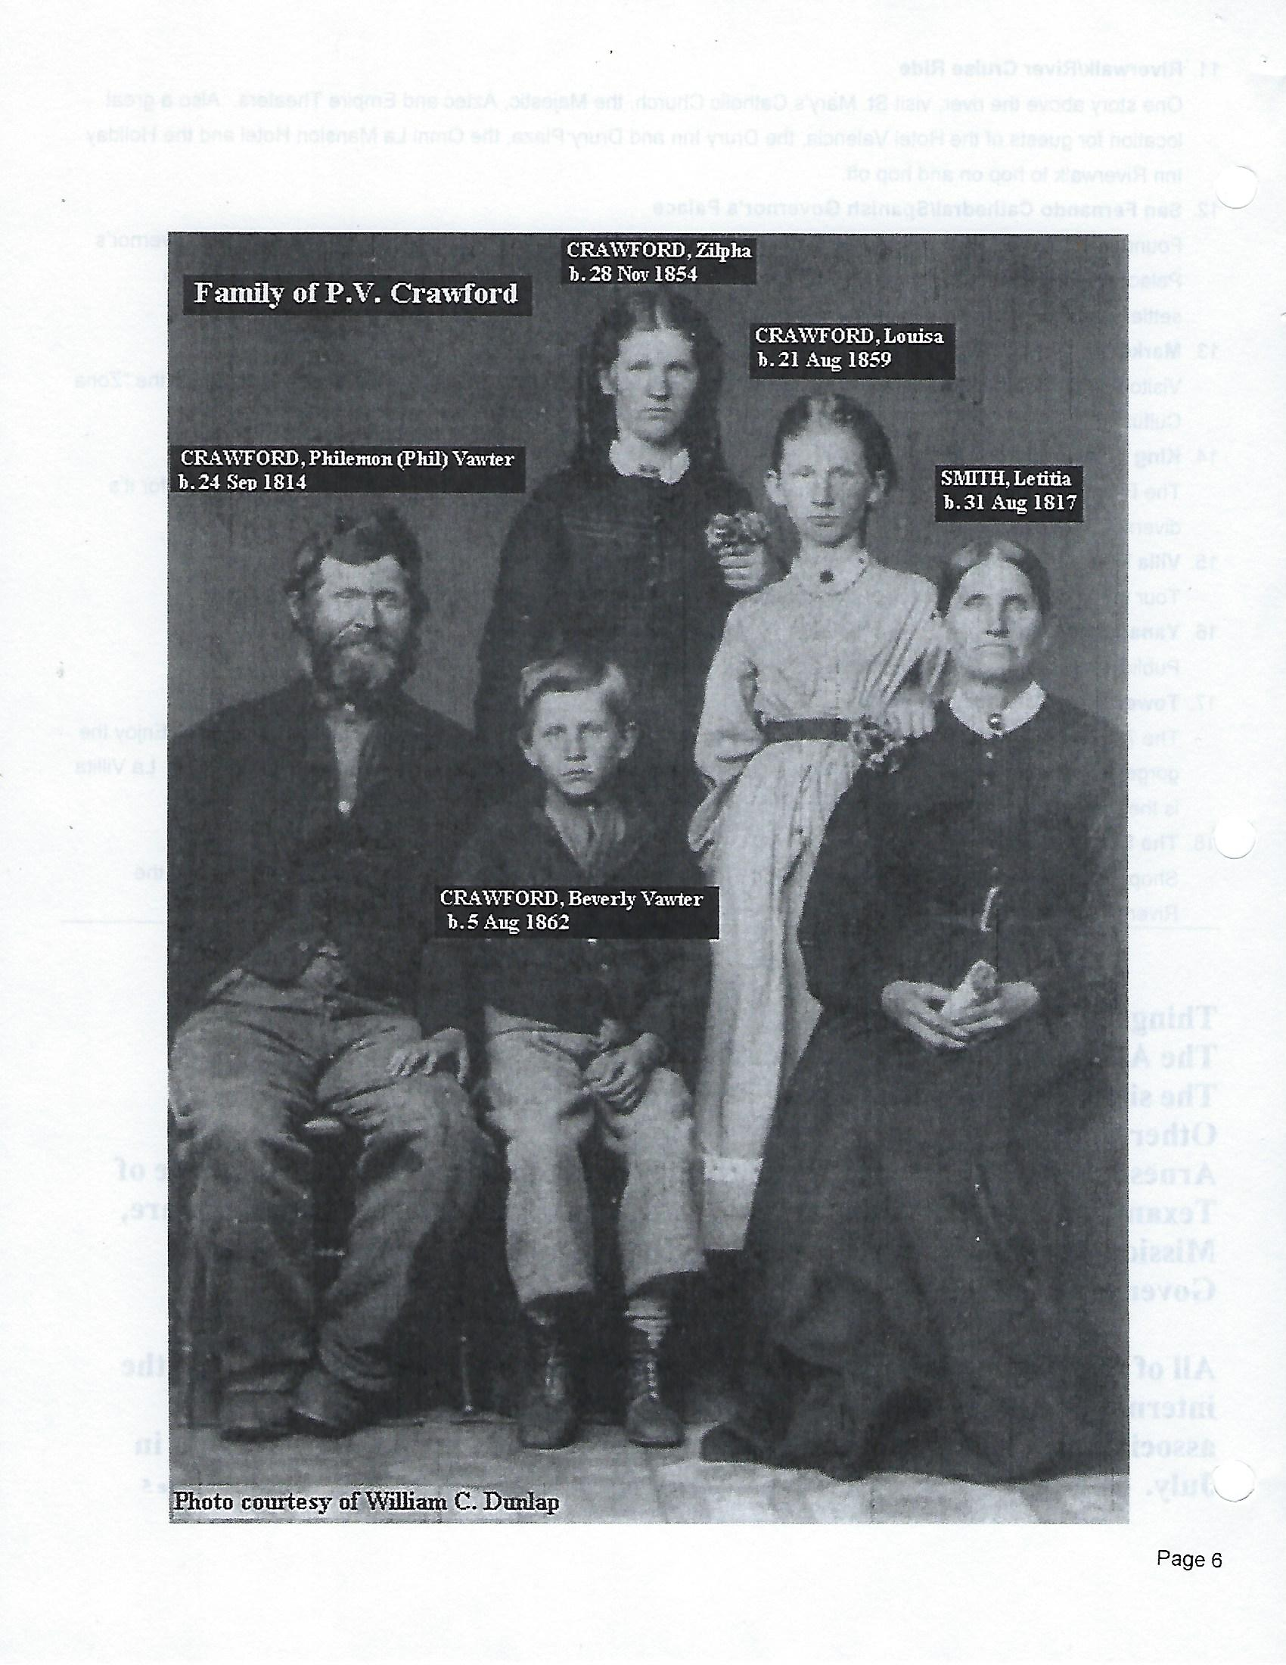

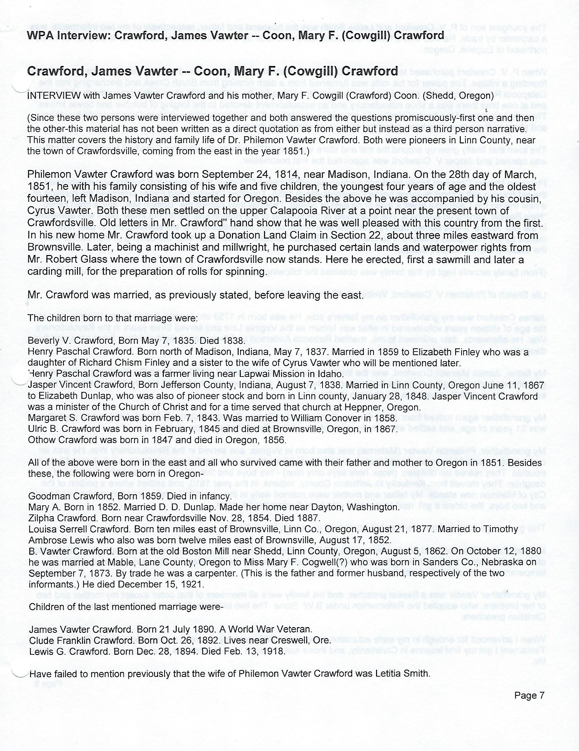

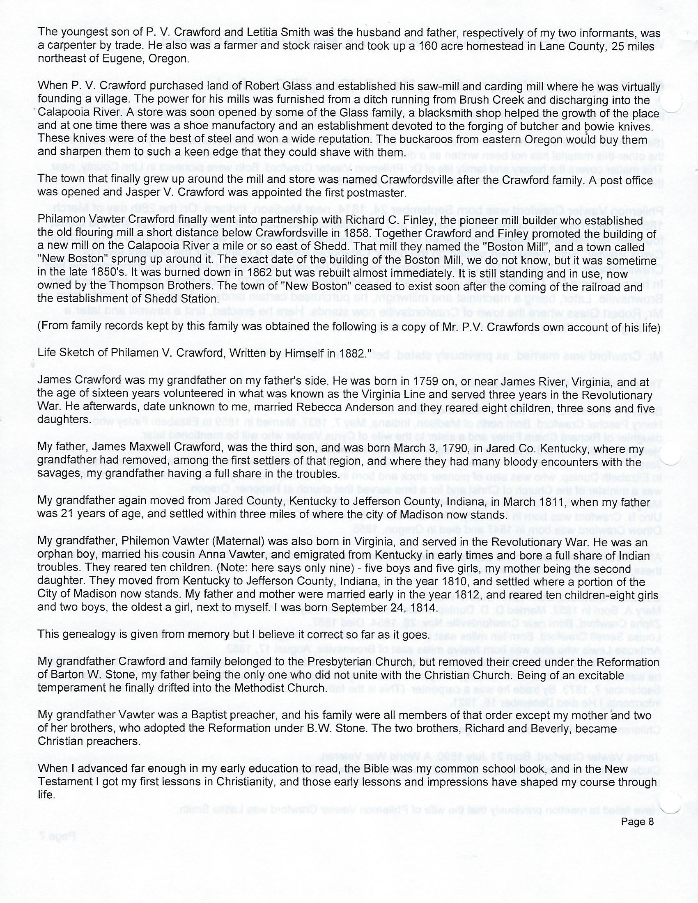
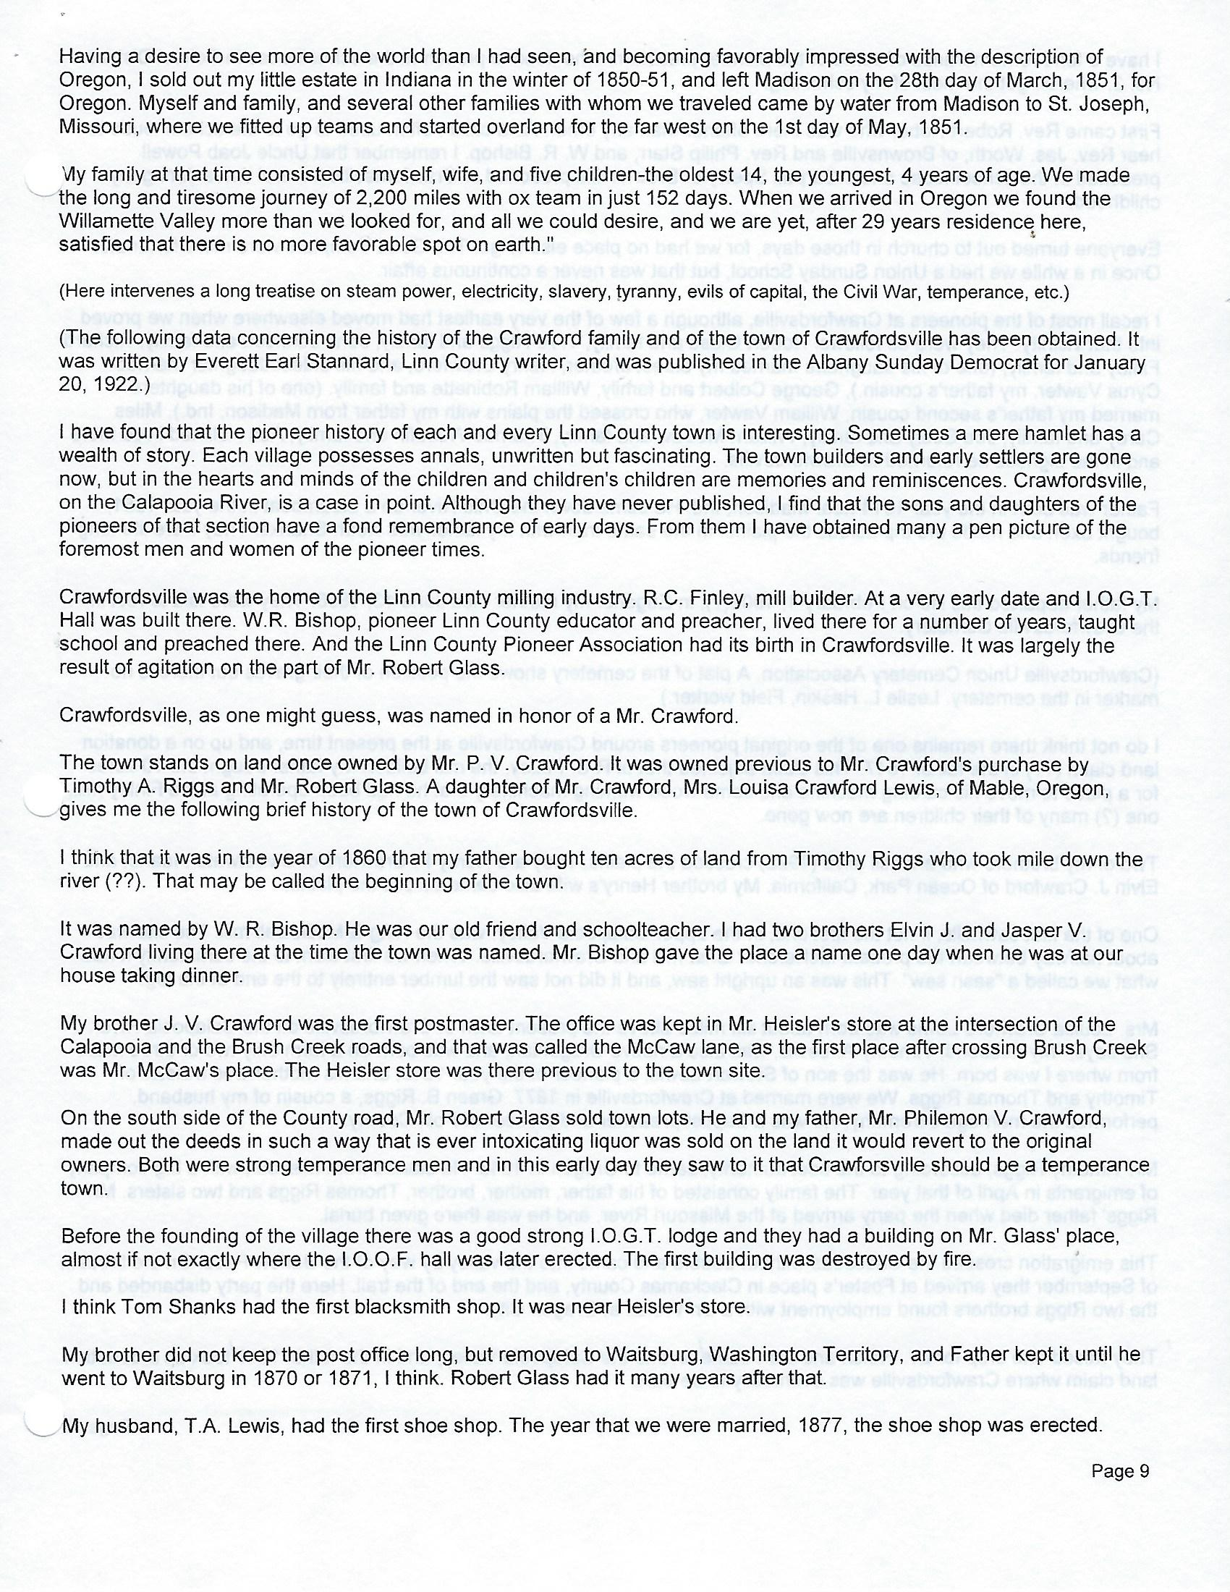

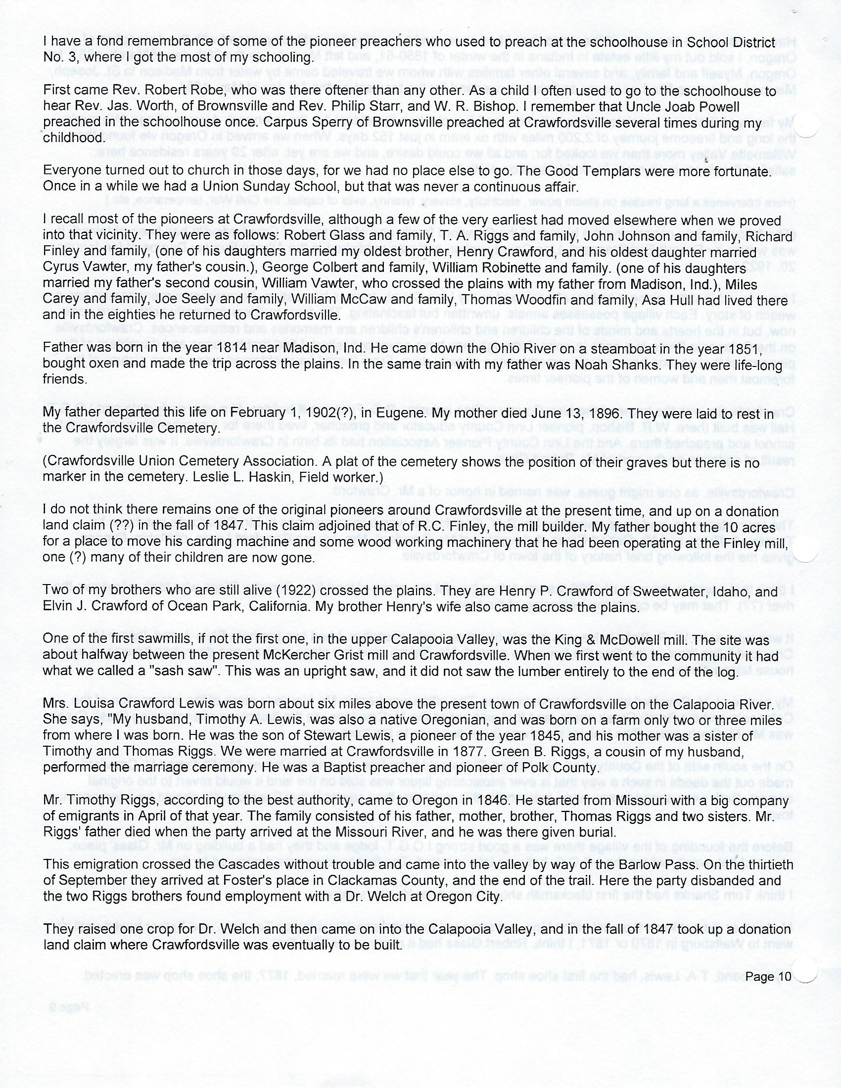

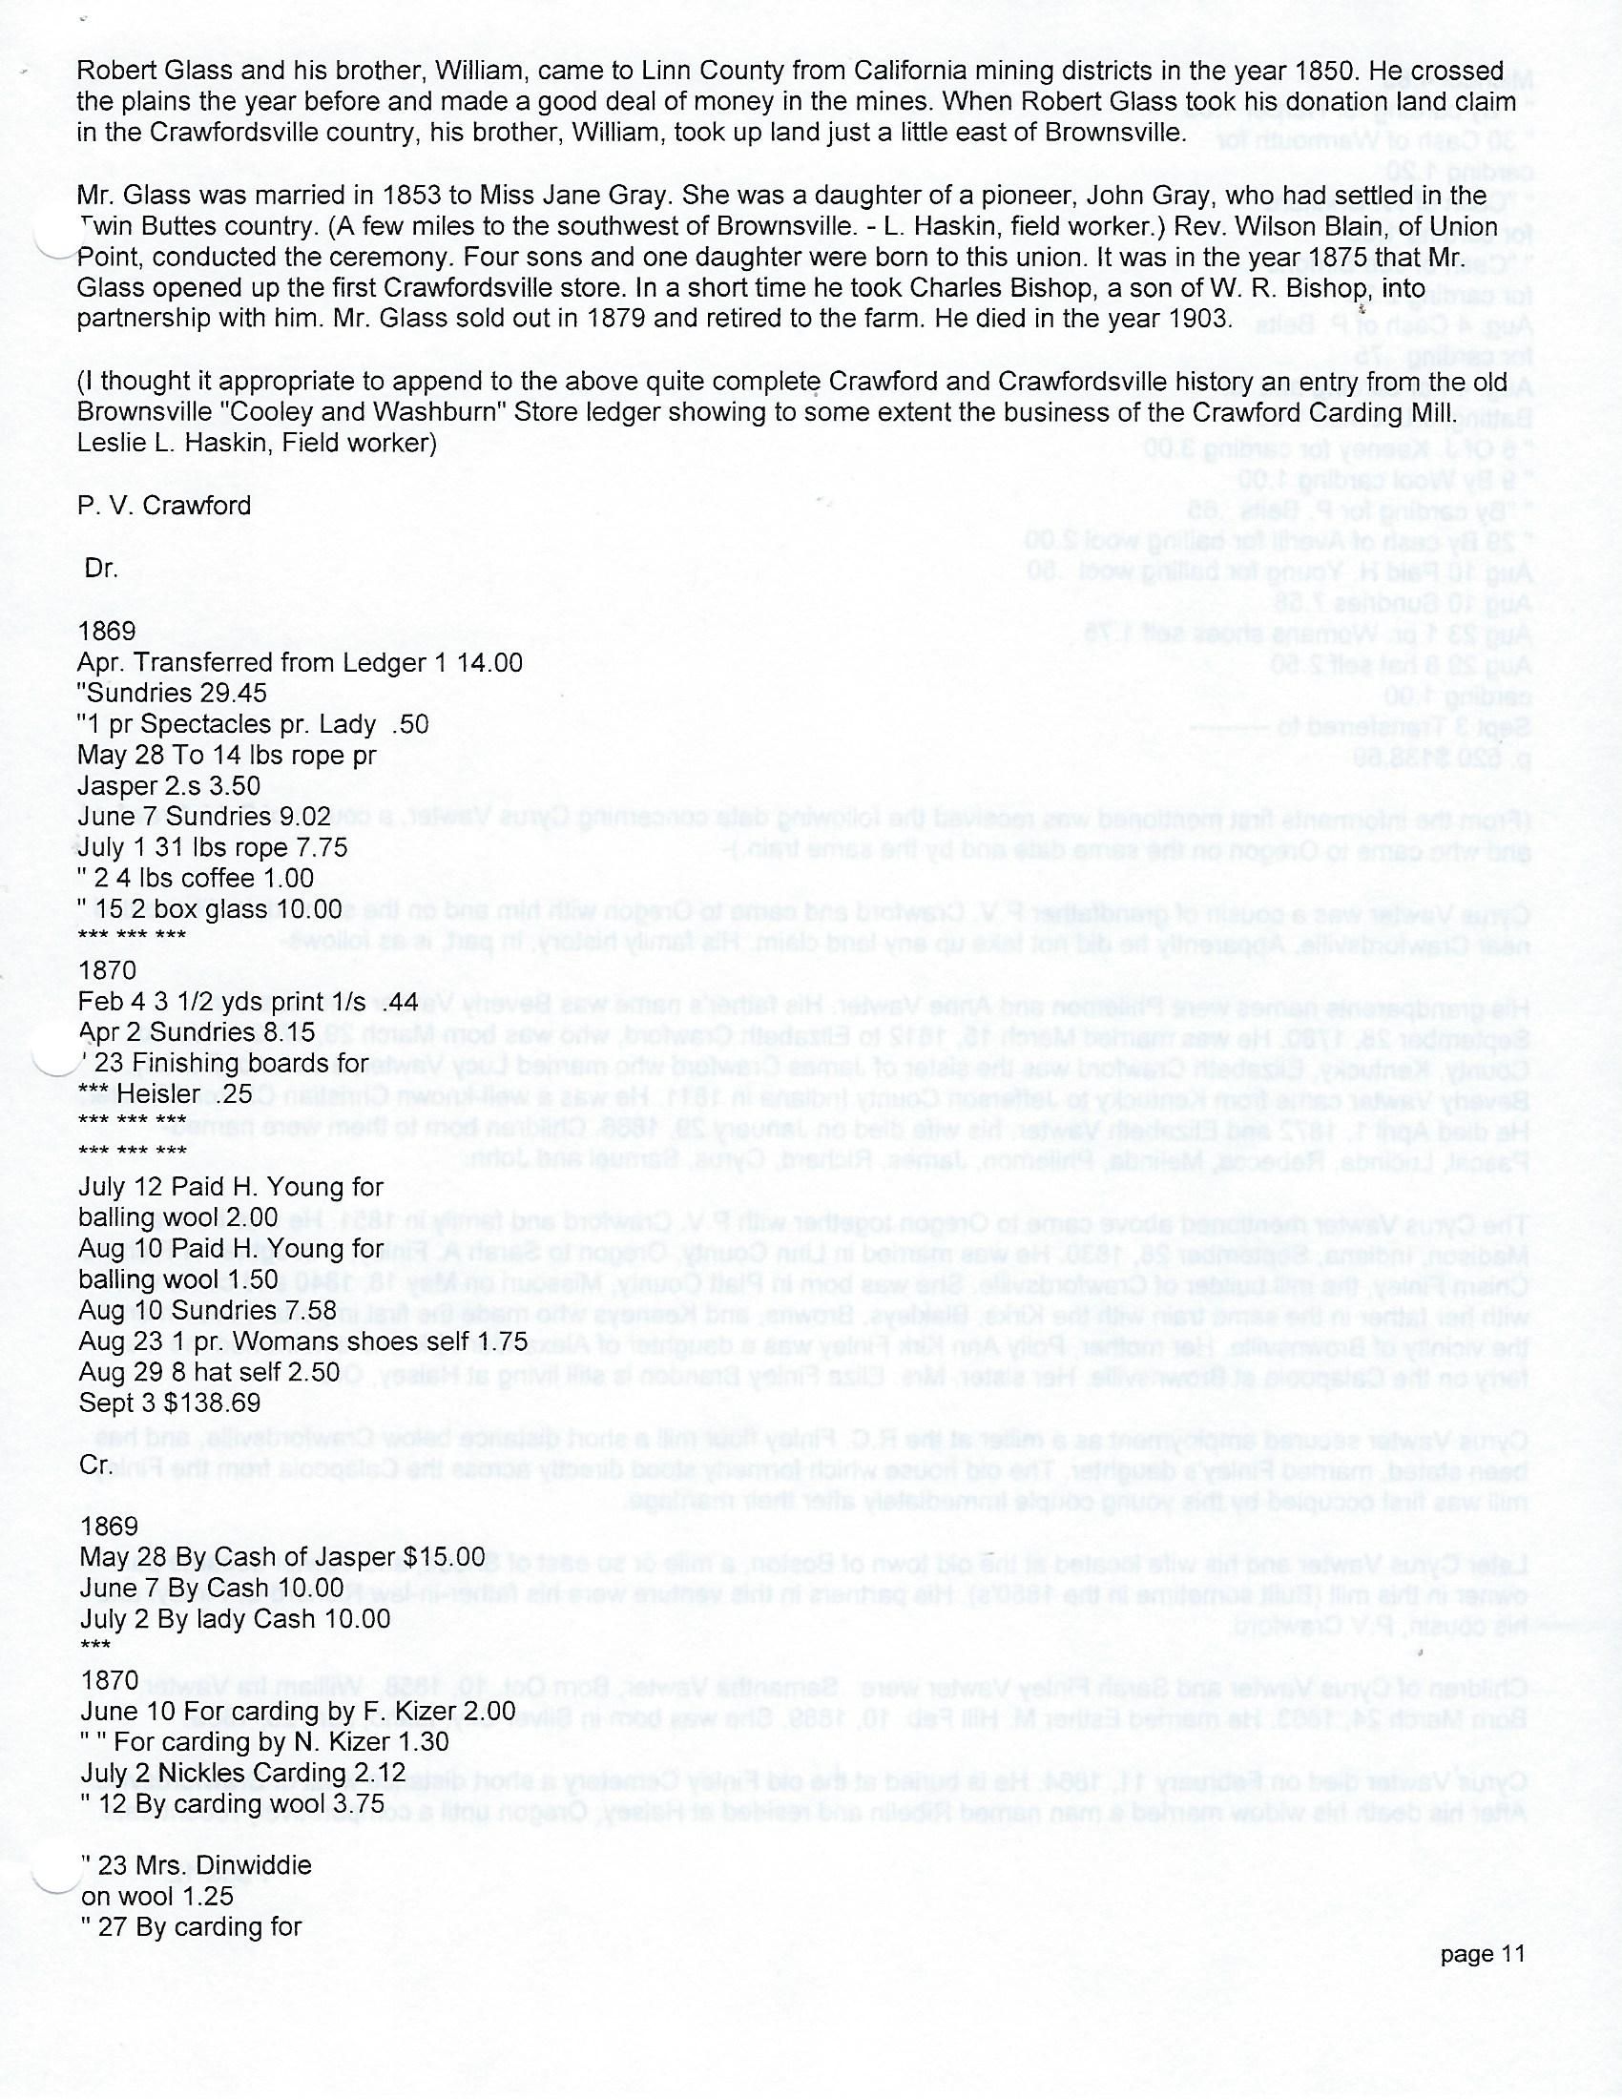

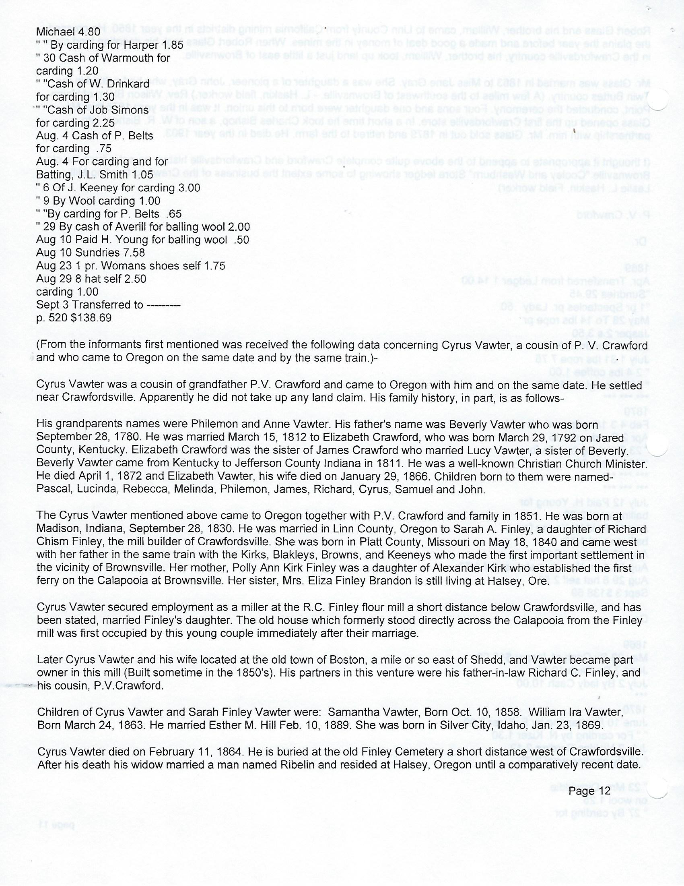

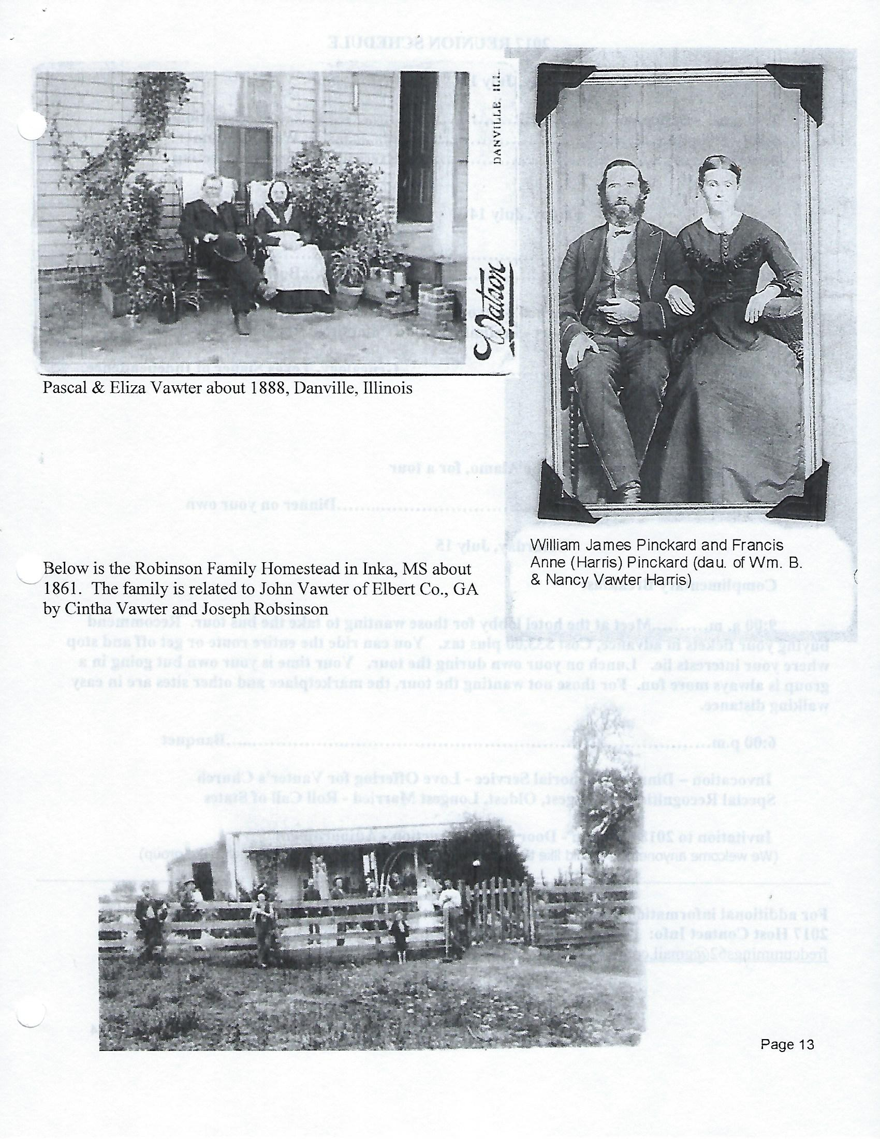

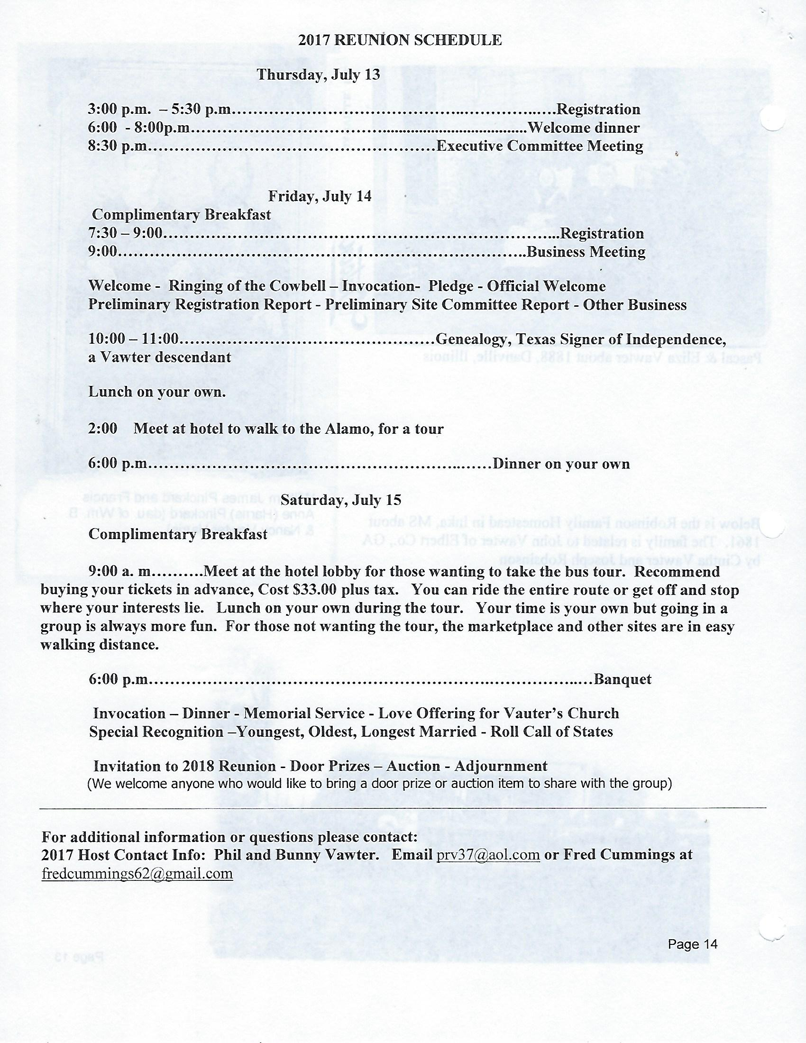

Dedicated to finding Vauter(s), Vawter(s), Vaughter(s)
Newsletter
September 2017 Volume 41 No 3
Reunion Dates:
Madison Indiana July 19-21, 2018
Topeka Kansas July 2019
Vauter’s Church, Virginia 2020

Website: www.vawterfamily.org
Officers
President Darren Welch, 402 N Galeston Ave, Indianapolis, IN 46229
Phone 317-899-1992 email: Darren.welch@cnoinc.com
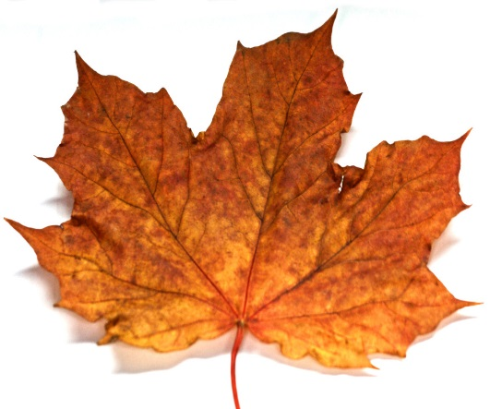Vice President Robert L. Vawter, 3773 Piper Bay Ln, Lakeland, TN 38002
This Photo by Unknown Author is licensed under CC BY-SA
Email: vawter.bob@gmail.com
Treasurer Jordan M. Johnston, 2450 Bear Creek Road
Pipe Creek, TX 78063 Phone 623-242-9296 email: .jjohnston3200@email.com
Asst. Treasurer Phil Vaughter, 1103 Newport, Austin, TX 78753
Phone…512-836-3105 email: PRV37@aol.com
Secretary Michelle Alexander, 489 Nannie Neal Rd, Hardin, KY 42048 email: mrax3@juno.com
Archivist Beth Melton, 3809 Junker, Rosenberg, TX 77471
Phone 281-232-7972 email: emeltonea@aol.com
Newsletter & Georgene Jurgensen, 8408 Mohican Ave
Genealogist Brooksville, FL 34613
Phone…816-591-0251 email: gfjurgensen@gmail.com
Website & Patricia Renton, 2372 Bear Creek Rd, Pipe Creek, TX 78063
Newsletter Phone…830-510-4625 email: pvrenton@gmail.com

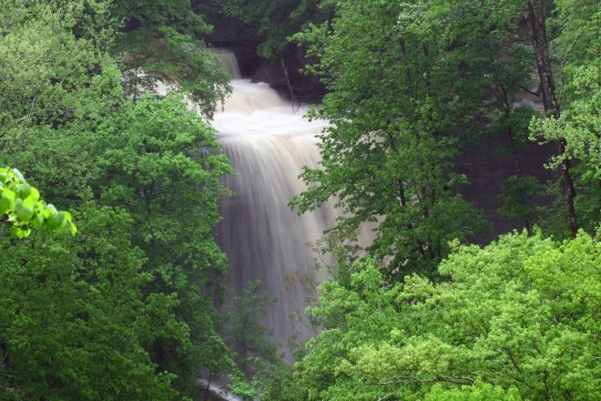
VVV Family Reunion
July 19 – 21, 2018 in Madison, Indiana

(Picture of Clifty Park)

In 1982, the VVV Family Association reunion was held at Clifty Falls State Park in Madison, Indiana, with about 127 members and friends attending from 22 states and Mexico. Also with us was an exchange student from Bogota, Colombia. Since then, we have had two other reunions in Indiana: Columbus in 1987 and Nashville in 1999, but have not returned to Madison.
That will change July 19 - 21, 2018, when the association once again gathers at Clifty Falls State Park for our annual reunion. Located along the Ohio River, Madison is in the part of Indiana first visited by Jesse Vawter in the early 1800s. According to some accounts, that visit was December 1805. Several of our members are descended from Jesse or his brother Philemon (and some descend from both brothers), and this will be an opportunity to learn more about our Indiana ancestors and cousins. We plan to honor their memories by placing flowers on their graves. Time will be spent in Madison, as well as traveling about 20 miles north to Vernon and North Vernon, where the Vawters also settled.
When looking at the names of those who attended the 1982 reunion, we realize that grandchildren and great-grandchildren of those attendees are now a part of the association. Michelle Alexander, current secretary, is the third generation of her family to serve as an officer.
Information about reservations at the Clifty Inn will appear in the December newsletter. Hosts for the 2018 reunion are Bonita Welch; her son, Darren Welch; and his children, Will and Anna.

In Memoriam

Aug. 16, 1948 - June 5, 2017 Paul Michael Vawter of Everett, WA, passed away peacefully on June 4, 2017. He was surrounded in love by his sons, Alan, Jacob and Isaac Vawter, his brother, John Vawter, nephew, Zac Vawter and his partner of 24 years, Colleen Robinson, as he passed. Paul was a proud Marine, enlisting in 1967 at the height of the Vietnam War - he didn't wait to be drafted, and worked his way through two medical exams to become a Marine. After completing his enlistment, Paul moved to Fairbanks, AK, with Bendix Field Engineering to track satellites for NASA. Paul returned to Washington State in 1981 to work at Honeywell as a VAX Systems Administrator. In 1987, he joined ATL as a Data Center Manager, working there until 1990. He then joined Snohomish County PUD as a SCADA Engineer until his retirement in 2010. At PUD, Paul kept the lights on for all of Snohomish county. Known for his Andy Rooney style eyebrows and contagious laughter,

Paul had a lifelong love affair with hot black coffee, a good glass of whiskey and never letting the facts get in the way of a good story. He lived his life exactly the way he wanted to. His favorite hunting trips were taken with co-workers from PUD, coming home with wild turkey for the freezer. He enjoyed fishing of any kind and spending time with his sons on the water, where he was always at peace. Paul's favorite quote was "it was a great system until you added the users." His family would like to thank the outstanding staff of Providence Regional Medical Center - ICU nurses Lindsey, Chris, Tiara, Stephanie, Troy, Brent, Laura and Elisha; respiratory therapists Scott, Krista and Daryl; and Doctors Hartung, Tsen and McGoodman who brought peace, comfort and dignity to Paul's last days.

Paul was born in Longview, WA, to Forest and Clementine Vawter. Paul is survived by his mother, Clementine, sister, Linda, brother, John (Pam), and his three sons Alan, Jacob and Isaac (Laura), all of whom he loved and touched deeply. He was preceded in death by his father, Forest. Beloved by his friends and family, Paul was a constant source of joy and strength to everyone who knew him. A memorial service will be held from 6:00 p.m. - 8:00 p.m. on Friday, June 16, 2017, at the Snohomish County PUD Electric Building Headquarters, 2320 California Street, Everett, WA 98201 in the Commission Meeting Room. In lieu of flowers, please make memorial donations in Paul's name to Providence General Foundation to support the mission and work of Providence Regional Center Everett.

Page 2

Keith A. Vawter, 69, of Noblesville, passed away on Friday, June 16, 2017. He was born on August 3, 1947 in Boone County, Indiana. Keith was an avid golfer and the owner of a commercial construction company in New Castle, Indiana, before retirement.
He is survived by his wife, Janet (Ringer) Vawter; son, Daniel (Vinny Alaimo) of Florida; and daughter, Marsha (Mike) McMillen of Noblesville. The highlight of Keith's life was his two granddaughters, Brooklyn and Kayla McMillen. He is also survived by his mother, Betty (Merrill) Vawter; brother, Phil (Tina) Vawter; sister, Pam (Bill) Hintalla; and sister-in-law, Wanda Vawter. His father, Samuel Vawter, and brother, Richard predeceased him.

Laura Beth (Coppedge) Vawter, 85, of Clarkston, died Saturday, May 20, 2017, in her home surrounded by her family. Laura was born Nov. 16, 1931, in Greeley, Colo., to William Bruce and Annie Laurie Coppedge. She had two brothers and three sisters. The family moved to Burbank, Calif., when Laura was 5, and while in California, Laura and her brothers and sisters worked as extras in the motion pictures. In 1944, they moved to Idaho. She graduated from Burley High School in 1949 and then attended nursing school in Boise. Laura and Glenn were married Aug. 13, 1951, at the Community Church of Santa Rita, N.M. They were blessed with three children: Glennda (Mike) Griffin of Grangeville, Marla (Tom) McCue of Beaverton, Ore., and Roger (Tish) Vawter of Idaho Falls.
Laura worked for Syringa Hospital in Grangeville and later for Grangeville Elementary School. After Laura and Glenn's retirement, they enjoyed many years traveling in their motor home and spending winters in Arizona. In 2006, they built a home in Clarkston overlooking the Snake River. They gardened together and she raised beautiful flowers. Laura also enjoyed knitting, painting the ducks and songbirds Glenn carved and spending time with family. She made beautiful afghans for each family member to mark special occasions. Laura collected dolls and bells, keeping meticulous records. Laura and Glenn also golfed together and enjoyed playing cards with friends in Idaho and Arizona. Laura was an active member of Clarkston United Methodist Church, P.E.O., Doll Club and Garden Club, volunteering her time and creating lifelong friendships.
Laura is survived by her three children; sisters Jan Brown of Tigard, Ore., and Cheryl Caldera (Augie) of Clovis, Calif.; brother William Bruce Coppedge Jr. (Donna) of Modesto, Calif.; grandchildren Karla Staihar of Hillsboro, Ore., Jeremy Burress (Tiffany) of Hillsboro, Sarah Shepherd (Robert) of Lewiston, and Tammi Schneider (Troy) of Tigard; seven great-grandchildren: Natalie and Jonathan Staihar, Samantha and Alexandra Burress, Claire Shepherd, Trey and Tarin Schneider; and many nieces and nephews. Laura was preceded in death by her parents; sister Marjorie Atkinson; brother James Coppedge, infant brother Michael Coppedge; infant grandson Michael Griffin Jr.; and her husband of 65 years, Glenn Vawter.

Page 3
William G. Cutler’s History of the State of Kansas, Cowley County, Part 11, Biographical Sketches.
M. B. VAWTER, surgeon-dentist, was born in Kentucky in 1857, son of David J. and Susan B. Vawter. He was educated in his native State; he attended the dental department of the University of Louisville, Ky.; he commenced the practice of his profession in 1876 in Kentucky, where he remained for three years. He came to Kansas in 1879, located at this place; his office is located on the corner of Summit street and Fifth avenue; devotes himself exclusively to his profession. He was married in 1882 to Miss Alma Dixon, daughter of B. H. Dixon. He is a member of the Episcopal Church and of the Masonic fraternity, also of the Independent Champion of the Red Cross.
Arkansas City Traveler, September 14, 1881. The farewell party, given by Miss Lillie Chamberlain at the residence of Mr. and Mrs. Charles Schiffbauer, on Tuesday evening of last week, was one of the grandest events of the season. The full moon shown down like an immense headlight, viewing apparently, with the many Chinese lanterns that were pendant from the surrounding trees, making the scene resemble that of fairy land rather than reality. After some time spent in promenading through the beautiful grove of fruit and forest trees, the party’s attention was directed to an immense platform prepared for the occasion, where Prof. Farringer, with the string band of Winfield, had taken position, and in a few moments it was filled with youth and beauty gliding through the graceful movements of the easy quadrille and mazy waltz. A gorgeous repast followed, then with spirits overjoyed, each of the party instituted all manner of fun and mirth, which had to be seen to be appreciated. Mr. Matlack produced a novel figure in the terpsichorean art that few ever witnessed before, while Cal. Swarts furnished the music. To say it was an enjoyable affair don’t half express it, and for one, we hope to have the pleasure of again meeting Miss Chamberlain and her many friends under like circumstances. The Cornet Band did their best and filled the night air with delightful sounds for which the hostess came forward, and in the most charming manner, expressed her appreciation and thanked them for their kindness. The following ladies and gentlemen participated. Among others, Dr. Jamison and M. B. Vawter Arkansas City Traveler,
Arkansas City, January 31, 1881.
Dr. M. B. Vawter can still be found in his rooms over Matlack's store, where he will be happy to receive calls from those needing the services of a dentist. See his card.
CARD: M. B. VAWTER, DENTIST.
Office in Matlack's brick, Summit street, Arkansas City.
Artificial Teeth, $10 per set.

NOTE IN SAME ISSUE OF PAPER THE FOLLOWING NOTICE BY OTHER VAWTER.
CARD: Dr. JAMISON VAWTER,
Late Asst. Surgeon to the Louisville Eye and Ear infirmary.
Tenders his professional service to the citizens of Arkansas City and vicinity. Surgical dressings, and diseases of the eye, ear, throat, and nose (nasal catarrh), a specialty. Office in Matlack's brick.

NOTE: IN THE SAME ISSUE WAS THE FOLLOWING DISSOLUTION NOTICE.
DISSOLUTION NOTICE.
Notice is hereby given that the firm of Vawter & Loomis is this day dissolved by mutual consent.
M. B. VAWTER,
J. A. LOOMIS.

Arkansas City TRAVELER, MAY 24, 1882 MARRIED. Dr. M. B. Vawter and Miss Alma Dixon will be married in this city, at 9:30 o'clock this evening, at the residence of Dr. J. E. Shepard.
So readeth the cards

Page 4

1910 US Census Pasadena, Los Angeles, CA
Milton B. Vawter age 52 b. KY fb KY mb. KY Dentist owns business
Elma W. Vawter age 52 b. MO fb MD mb. NY 6 children 4 living
Jameson S. Vawter age 23 son b. KS
Milton B. Vawter age 21 son b. KS assistant Dentist
Joseph P. Vawter age 13 son b. KS

1920 US Census Alahambra, Los Angeles, CA dist 575
M. B. Vawter (Lawter) head age 62 b. KY/KY/KY
Alma N wife age 62 b. MO/MD/NY
Milton Jr. son age 29 b. KS/KY/MO
Joe B son age 20 b. KS/KY/MO
Muriel B. Hill dau age 35 b. KS/KY/MO
Charlotte L granddaughter age 8 b. CA/AR/KS

1930 US Census Pasadena, Los Angeles, CA Dist 1282
#852/75/75
Vawter, Dr M B Sr Head value $8000 age 70 married 23 years b. KY/KY/KY
Alma wife age 70 m. 23 years b. MO/MD/NY
Joe B. son age 28 b. KS/KY/MO
Sarah Shepard sister in law age 83 b. MO/MD/NY

1930 US Census, Los Angeles, CA dist 115
Milton B. Vawter age 41 b. KS property value $10,000 Dentist
Ava Vawter age 39 b. KS
Patsy Vawter age 1 y 10 m b. CA

Arcadia Tribune (Arcadia, CA) 18 Jan 1935
Dr. M. V. Vawter, 846 North Golden West Avenue, who suffered a stroke of paralysis over a week ago, is reported to be slightly improved today. J. H. Henderson, who has specialized in nursing, is caring for Dr. Vawter during his illness.

Historical Newspapers Los Angeles, CA 1937
Vawter, Dr. Milton B. Vawter, aged 78 years, in South Pasadena, June 10. beloved husband of Alma U. Vawter, father of Mrs. E. D. Hill of South Pasadena and Dr. M. B. Vawter, Jr. of Los Angeles, and Joseph Vawter of Arcadia; brother of Mrs. C. A. Doughty of Alhambra and Dr. Jamison Vawter of Arkansas City, Kan. Funeral services Saturday, June 12, at 2pm at the chapel of Turner, Stevens and Turner, Alhambra. Interment San Gabriel cemetery.

Historical Newspaper Los Angeles, CA 1938
Vawter, Alma D. Vawter in South Pasadena, December 16, loving mother of Mrs. Edwin D. Hill, Dr. Milton B. Vawter and Joseph Vawter. Private funeral services Tuesday, December 19 at 10:30 am at the chapel of Turner, Stevens & Turner. Alhambra, Interment San Gabriel Cemetery.

Historical Newspapers Los Angeles CA 1940
Vawter, Dr. Milton B., beloved husband of Ava Vawter; father of Patsy Suzanne Vawter; brother of Mrs. Edwin D. Hill of South Pasaden. Services Wednesday at Edwards Brothers Colonial Mortuary.

Page 5

Kansas and Kansans Volume 3

Mr. Dixon is a native of Kansas, born at Caldwell August 5, 1875. His people have lived in America for a number of generations. The Dixons came originally out of Ireland and were colonial settlers in Maryland. Until the Civil war the Dixons were slave holders. Mr. Dixon's grandfather, Benjamin Harrison Dixon, was born near Church Creek, Maryland, in 1812, grew up and married there, and then came West and settled near St. Joseph, Missouri. He was there before the railroad, and St. Joseph was chiefly Important as a river town and a supply point for the West. He acquired a large estate and became a shipping contractor, sending freight across the plains to the Rocky Mountains and further. He owned slaves, and early in the Civil war, because of that fact and because of his pronounced Southern sympathies, was driven out of Missouri and went to the vacant prairies of Nebraska. He died at Caldwell, Kansas, in 1884. He married Aurelia Wilcox, who died near St. Joseph, Missouri. Five of the children of these grandparents are still living, namely: Charles B., a farmer near Ponca City, Oklahoma; Sarah B., who lives at Alhambra, California, widow of Dr. James Shepard, who was a physician; Alma is the wife of Dr. M. B. Vawter, a dentist at Alhambra, California; Carrie married H. H. Davidson, a shoe merchant at Los Angeles, California; and Dorcas resides in Arkansas City, the widow of William Stewart, a farmer.

VIRGINIA DUELLING. During the war of 1812 there were a number of duels among army officers. Col. James Bankhead, afterward General, grandfather of Gen. J. B. Macruder, and Buckner fought in Vauter's church yard, in Essex county, but after firing once they were reconciled.

The Roanoke Times, Volume 10, Number 101, 15 January 1892
Miss Josephine Vauter, who has been visiting Miss Maggie Ott, returned to her home near Charlottesvllle yesterday.

The Twentieth Century Biographical Dictionary of Notable Americans:
Volume X Stoughton, William Lewis
STOTT, William Taylor, educator, was born in Vernon, Ind., May 22, 1836; son of the Rev. John and Elizabeth (Vawter) Stott; grandson of the Rev. William T. and Mary A. (Wilkinson) Stott), and of the Rev. William and Frances (Vawter) Vawter, and great-grandson of Raleigh Stott and of Jesse Vawter. He was graduated at Franklin college, Ind., in 1861, and enlisted in the 18th Indiana volunteers; served as private two years and as captain two years, and commanded his regiment in the battle of Cedar Creek, Va. He was graduated at the Rochester Theological seminary in 1868, and on May 21, 1868, was married to Arabella Ruth, daughter of Isaac Storrs and Mary M. (Pierce) Tracy, of Rochester, N.Y. He was pastor at Columbus, Ind., 1868-69; professor of natural sciences at Franklin college, 1869-72, and became president of Franklin college in 1872. He received the degree of D.D. from Kalamazoo college in 1872, and that of LL.D. from Shurtleff College in 1899. He was president of the Indiana Baptist convention in 1875, and in 1898 became associate editor of the Baptist Outlook

A letter from the Dept. of Archives & history State of MS, 19 Mar 1941, the following are listed as confederate soldiers (found in William Snyder Vawter papers)
1. J. N. Vauters, Private, Co A, 2th Reg. of MS Inf. , CSA. Enlisted 17 Aug 1861
2. James E. Vawter, Private, Co I, 12th Reg of MS Inf, CSA. Co I known as the Durant Rifles, of Holmes Co., and was mustered into the state army, 15 Mar 1861.
3. John Vawter, Private, Co D, 2nd Reg. of MS Cavalry, CSA. DO D was known as the Senatobia Opposers, and he enlisted at Senatobia, Tate Co., MS Apr 1862.
4. J. N. Vawters, Private, CO I, 22nd Reg. of MS Inf., CSA CO I was known as the Johnston Avengers, and was organized 25 Mar 1962.
5. Rolly A. Vaughter, Private, CO A, 14th Reg of MS Inf, CSA. CO A was known as the Winston Guards, and was mustered into the State Army at Louisville, Winston County 16 Mar 1861.
Page 6

The 2017 Reunion in San Antonio, Texas is history, but many memories remain. If you want to see all the family pictures, go to the Vawterfamily.org site and click on the small box at the top noted as “pictures”. Click on the 2017 slide show and enjoy. Other reunion pictures are also shown. Here are just a couple of highlights. Hope to see everyone at the 2018 reunion in Madison, Indiana.
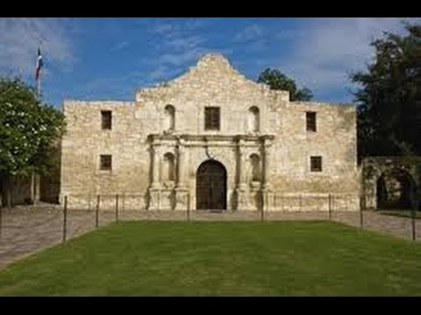

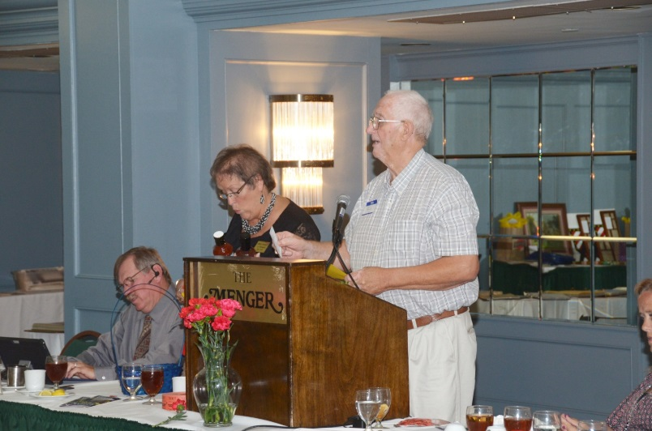

Members had a great time at our auction and funds raiser for the Vauter’s Church in Virginia. Our annual Memorial Service was beautiful as always and we remember our veteran’s and members past and present.
Members from various states were noted, with Texas being the biggest group this year. President Darren Welch did an outstanding job.
Several members brought old pictures and genealogy data to share.
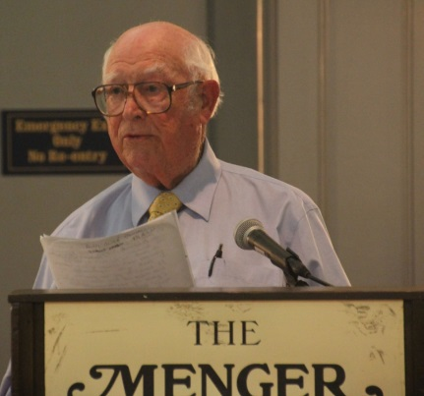
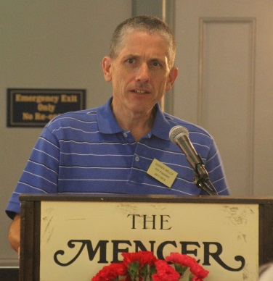
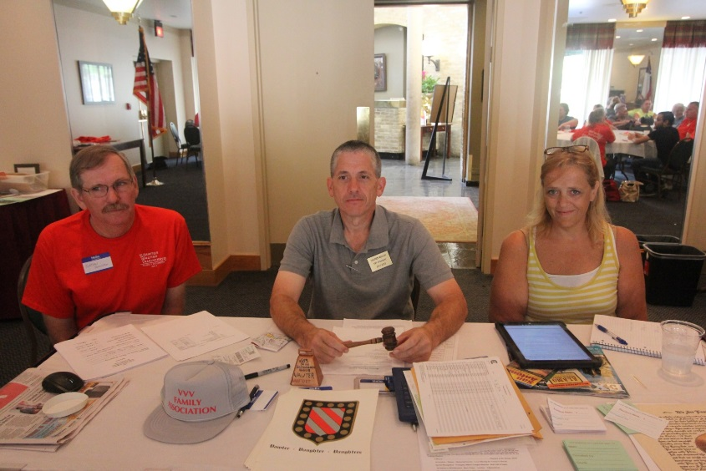

At the 2017 Reunion in San Antonio we talked about Vawters in Texas. David Vawter and his wife Lucinda were early arrivals. I promised the group I would publish the famous cookie recipe. Perhaps someone can bring them to the next reunion. Not many families can boast a 175 year old recipe.

The Vawter Plantation in Louisiana was a center of hospitality, as were many of the plantations of the south. Governors, senators, writers and artists were among its guests. All were enthralled by the unusual foods prepared by the wrinkled colored cook. They especially complimented the Sorghum Molasses Cookies and often asked for them on subsequent visits.

From the book Romantic Recipes of the Old South, copy right 1950 by Imperial Sugar Co., Sugar Land, TX comes the following:
Cookies
1 cup molasses 1 cup boiling water 2 teaspoons salt
1 cup sugar 1 tablespoon ginger 6 cups flour (enough for stiff dough)
1 cup butter 4 teaspoons soda

Combine molasses, butter and sugar in sauce pan; place over low heat until mixture begins to boil. Add 1 cup boiling water and ginger. Pour into large mixing bowl and stir in 2 teaspoons of soda. (This makes a foamy mixture) Add flour sifted with salt and remaining 2 teaspoons of soda. Mix well. Chill dough and then roll thin and cut into desired shape. Place 1 inch apart on greased cookie sheet. Bake in moderately hot oven (375) for 10-12 min. Makes 7 dozen, 3 inch cookies.

David Vawter b. 21 Jan 1800 in KY d. 13 Jul 1845 m. 23 Apr 1823 to Lucinda Glover (sister of James Glover). Lucinda b. 8 Jul 1805 d. 20 Dec 1857. David traded down the Ohio and Mississippi rivers, running to Natchez and New Orleans. In 1832, he built his first steamboat, the Bravo. He later owned a number of steamboats running on the Mississippi and as high up the Red river as they could go. He sold out and moved to Texas in 1844 where he bought a large tract of land. David died one week before his mother’s death.

Harrison County, Texas, Deed Book C, page 405
THE REPUBLIC OF TEXAS
COUNTY OF HARRISON
DAVID VAWTER, Bond for Ferry across Sabine

Know all men by these presents that I, DAVID VAWTER, Principal, & SETH SHELDON, Security, are held and firmly bound unto L.H.Dilliard, Chief Justice in office of said county, in the penal sum of one thousand dollars, good and lawful money for the payment of which, well & truly to be made, we bind ourselves, one and each of us, our heirs and assigns, severally & firmly by these presents. Signed and sealed this 3rd day of September 1844. The condition of the above bond is such that whereas the above bound, DAVID VAWTER, has obtained a License to keep up and establish a Ferry on the Sabine River at the GRAND BLUFF. Now if the said, VAWTER, shall well and truly comply with the law respecting the establishment of a Ferry, then this obligation to be null and void, otherwise to remain in full force & virtue this day & date above.
DAVID VAWTER (seal)
SETH SHELDON (seal)
Approved, 3rd September 1844
L.H. DILLIARD, Chief Justice of Harrison County (seal)

From the newspaper Panola Watchman, Carthage, Texas, April 27 & May 4, 1975
Perhaps the Grand Bluff Ferry across Sabine River provided a gateway for more settlers to Panola County, and to East Texas in general, than did any other crossing on the river. A busy village grew up in the vicinity of the bridge on the old road to Marshall. Only a few reminders are present now to acquaint the visitor with what once transpired there. It is truly a “ghost town”. The original settlement was situated on a high bluff on the west bank of the river and a cemetery was located about one-half mile down river. There are many unidentified graves, at least a hundred. A large mound of crumbling brick vaults near the center of the cemetery is especially interesting. One mound covers six or more graves. In addition, there are two single vaults at the end of the main family mound. Shells cover the tops of a good many graves. Cedar trees still living mark the head and foot of two graves. The cemetery boundaries are not difficult to locate, as the fallen fence is still to be found in sections entirely around the plot. Though the last gravestone date of death is 1898, some mulberry posts are still standing.
Page 8
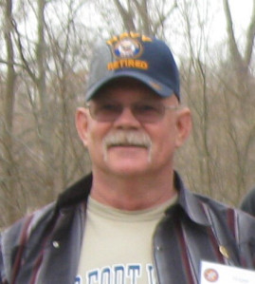

count Written by Elijah’s Son William Preston Stapp07MAR

Steve Bennett, descendant of William Preston Stapp
The account below was shared by one of William Preston Stapp’s descendants: Steve Bennett of Fort Worth. Steve is Elijah Stapp’s great grandson x3. . Elijah Stapp’s parents were Achilles Stapp and Margaret
Vawter.

This moving and descriptive account relates to the ill-fated Mier Expedition and the Black Bean Episode wherein Texans were captured (including William Preston Stapp) by Santa Ana’s army and some were executed. I really appreciate Steve sharing this with us!
From the Account of William Preston Stapp 1845. Jaded with the barbarous stages imposed on us in our fettered condition, and worn down with the severity of our morning’s tramp, we entered our former quarters (the corral of the ranch), and gladly sought repose for our wearied limbs upon the filthy floor of the shed that ran round the enclosure. The morning had been clear and beautiful, and the noon warm to sultriness; but a few miles before we reached the ranch the sky became suddenly overcast, and fierce gusts of wind came whistling along the plain, blinding us with clouds of sand, and whirling the heavy leathern caps of the cavalry from their heads as lightly as though they were children’s bonnets. So sudden and violent a transition of the element around us would have passed unheeded at any other time or place. But occurring on the eve of our return to a spot with which we were connected by memories of blood and violence, whose transactions vague rumor had also associated with some impending atonement, inspired a presentiment of approaching evil in the minds of most of us. Still there was nothing either in the communications or deportment of our guard along the road, to excite the slightest suspicion of their design, and by the time we had reached our pen and huddled under its shelter, the tempest began to lull and our apprehensions were departed.
But a few minutes had elapsed before a group of Mexican officers entered our quarters, and one of them, holding a paper in his hand, directed the interpreter to summon us around him, when he proceeded to read its contents in Spanish to the assembled prisoners. As no second order enforcing the execution of the one from Santa Anna commanding our deaths had been received at Saltillio, a hope had sprung up amongst many, that some possible clemency might be in store for them. A few, therefore, of the more sanguine, pushed their way into the circle, and bent their eager eyes on the reader, half expecting his communication to be a mandate for our release. Who can describe the thrill of horror and consternation that electrified every heart, when the interpreter, in broken and tremulous tones, announced it as an order from the supreme government, directing every tenth man amongst us to be shot! the lots to be decided on the instant, and the execution to follow immediately. So entirely unexpected was this murderous announcement, so atrocious in its character, and so inhuman and indecent in the haste of its consummation, that a stupor seemed to pervade the whole assembly, not a word escaping from the lips of any for more than a minute. The silence was at length interrupted by the interpreter, who, in obedience to his directions, proceeded to inform us further, that all had been sentenced to the same fate, but the humane government had been graciously pleased to commute the just claim to this decimal exaction.
Page 9

A low clatter of the handcuffs was now heard, as some of the most desperate of our fellows essayed to free themselves from their shackles. This had been foreseen and provided against. An order was promptly given us to fall back within the shed, and the doorway and top of the sunken wall bristled with the muzzles of muskets presented to enforce it. We were helpless as the bound victim under the sacrificial knife, and had no alternative but to obey.
Whilst we were marshalled in an extended file, a Mexican subaltern and soldier entered the yard together, bearing a bench and earthen crock. The bench was placed before the officer who had communicated the order, and the crock set upon it, containing one hundred and seventy-four beans, (the number of prisoners present amongst which were seventeen black ones. A handkerchief, so folded as to hide the colour of the beans, was then thrown over the crock, and a list of our names, taken down when we were recaptured, placed in the hands of the interpreter. When these funeral preliminaries were completed, the name of our dauntless leader was first called, who, with a step as stately and brow as serene as he ever previously wore, stepped forward and drew. Each name continued to be called in their order on the list, and the individual compelled to draw, until the seventeen black beans were taken from the crock. When a bean was drawn, it was handed to the officer, and the bowl well shaken before the lottery proceeded. As they drew, each person’s name was entered upon another memorandum, with the colour of his bean. In many instances the doomed victim was enforced to revisit the fatal urn, to allow the comrade to whom he was chained to try the issues of life and death. Appalling as was the first effect of the order, and rapidly and voraciously as our self-dug graves yawned around, not a step faltered, nor a nerve shook, as the sickening ceremonial proceeded. Several of the Mexican officers seemed deeply affected, shedding tears profusely, and turning their backs upon the murderous spectacle. Others again leaned forward over the crock, to catch a first glimpse of the decree it uttered, as though they had heavy wagers upon the result. Three-fourths of the beans were exhausted before the fatal seventeen were drawn. When the sacrifice was made up, the victims, names were called over, their persons scrutinized, and being removed outside, their irons were knocked off. A few of us were permitted to go out and take a hasty leave of them. A priest had accompanied the march from Saltillio, who was now present to offer them extreme absolution; but only two could be prevailed on to accept of his intercession. Major Robert Dunham, being importuned to confess him to the holy father, repelled the proposition with warmth, preferring, like a good Protestant, to shrive himself, which he knelt down and did mutely and earnestly. This brave and honest man was then solicited by the rest to offer up a prayer in their behalf; but, as he was about to comply, he was rudely stopped by the officer on duty, who sternly and profanely forbade it. As the hour of twilight advanced, two files of infantry, consisting of twenty men each, with the whole of the cavalry, escorted the doomed party to the eastern wall, selected as the site of their execution. Here, being made to kneel down, with their faces to their butchers, they were blindfolded and shot, in two parties, successively, nine first, and eight soon afterwards. Huddled together in the stalls of the corral, the surviving prisoners were forced to sit down, and a heavy body of sentinels placed over us, with their firelocks cocked and at a present, ordered to shoot the first man who should move or speak whilst the execution was progressing.
Tears forced their way down many a rugged cheek, as, silent and manacled, we listened to the mournful and plaintive notes of the dead march, swelling and sinking on the ear, as the procession rounded our prison, to the eastern flank of the ranch. The wall against which the condemned were placed, was so near us we could distinctly hear every order given, in halting and arranging the command for the work of death.

Page 10

The murmured prayers of the kneeling men, stole faintly over to us—then came the silence that succeeded, more eloquent than sound-then the signal taps of the drum-the rattle of the muskets, as they were brought to an aim-the sharp burst of the discharge, mingled with the shrill cries of anguish and heavy groans of the dying, as soul and body took their sudden and bloody leave. The names of the victims of this perfidious and most atrocious tragedy, were (spellings and full names modified from Stapp)

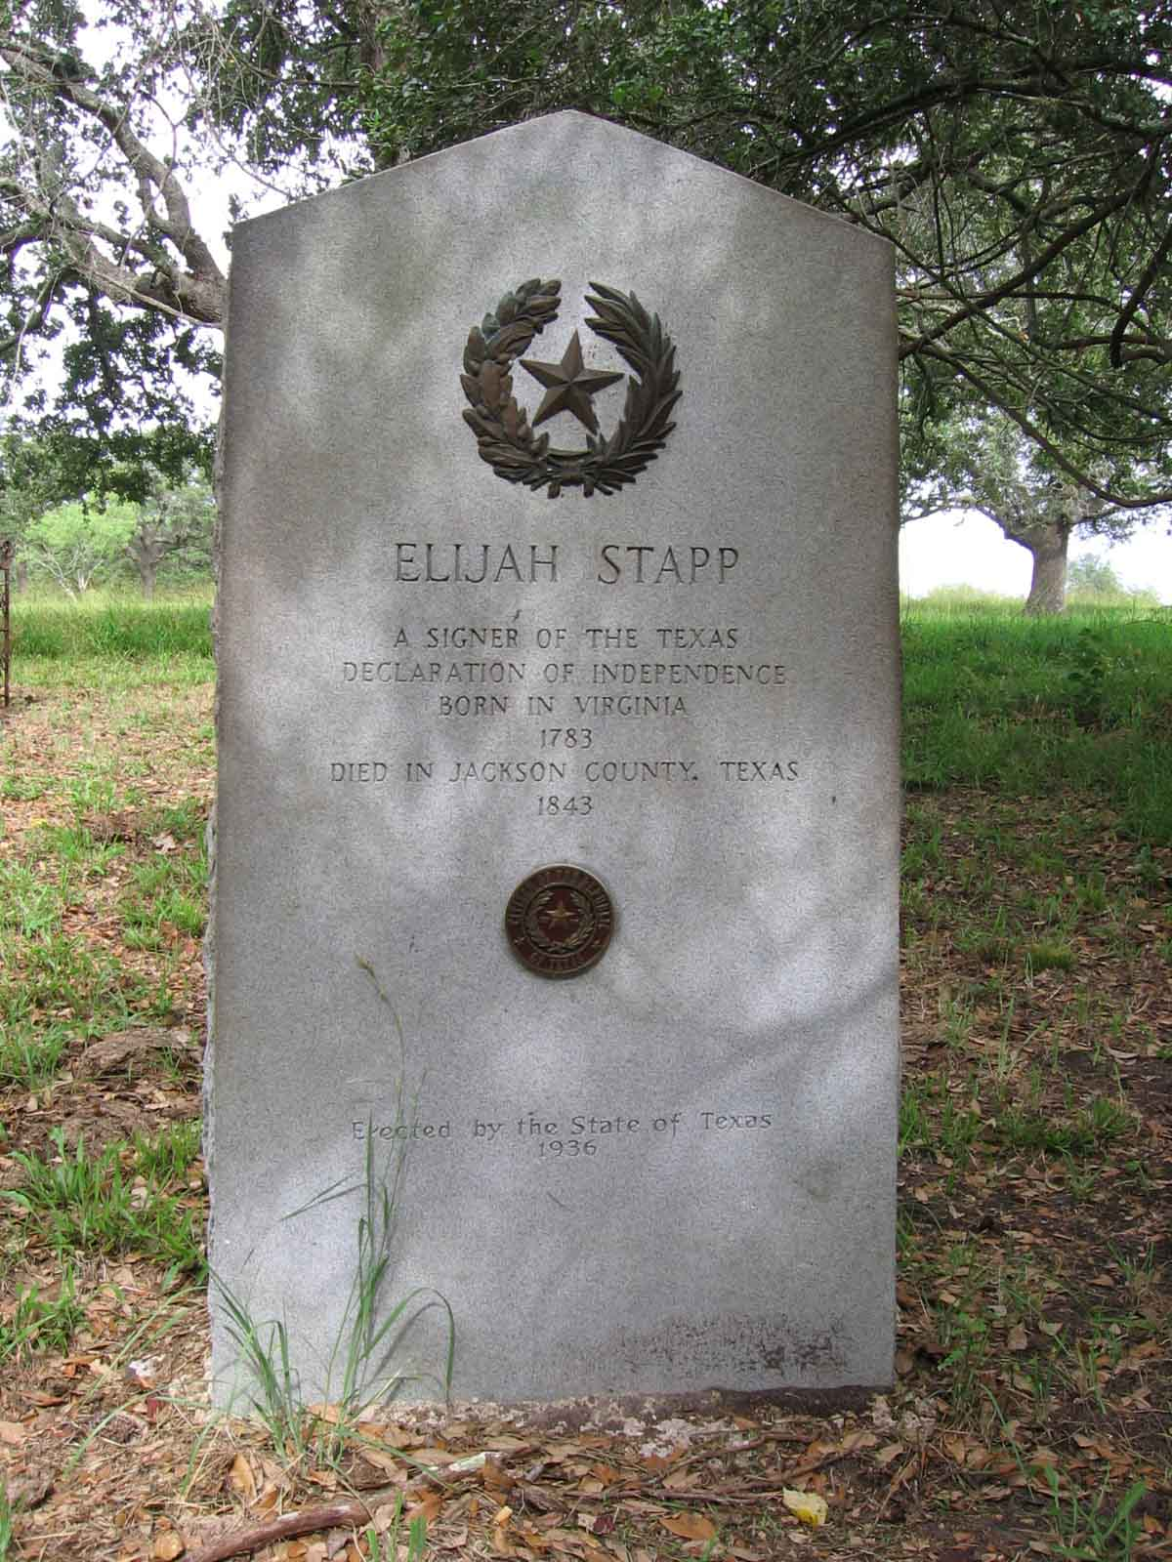
The above account was one mentioned during the genealogy meeting at the San Antonio meeting. I stated that it was too long to read and I would publish. Elijah Stapp, signer of the Texas Declaration of Independence and his story were the main topic of our event, but his son also served an important part of history. Many articles can be found on the internet about Elijah Stapp and his place in history.

Elijah “Ely” Stapp b. 16 Oct 1783 Orange Co., VA.
d. March 1843 Edna, Jackson Co., TX m. 16 May 1811 Woodford Co., KY. Nancy Shannon b. ca 1790
d. 13 Aug 1845 TX. (Elijah’s date of death also shown
as 21 Aug 1842)

In 1816 he moved to MO with his wife and two sons. While living there he heard stories of land and life in the Mexican Territory of TX. In 1826, he went to look it over and in 1831 he moved with his wife and six children to Jackson Municipality, in the contract colony of Green C. DeWitt.

On 16 Jul 1831, he was given title to a “league of land”. When the Mexican government closed Texas to further settlement of Americans he saw danger for his future. When the Consultation Convention was called at Old Washington-on-the-Brazos for 1 Mar 1836, Elijah was asked to stand for election as a delegate and was elected. The Texas Declaration of Independence from Mexico was drafted with Elijah signing as a duly elected delegate. He was also selected by the convention as one of the “Committee of 26” to draft the constitution that governed the Republic of Texas from 1836 until Texas was admitted to the Union in 1846.

Page 11

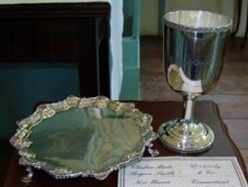

Vauter’s Church, Essex County, Virginia

Vauter’s Episcopal Church, the upper church of St. Anne’s Parish, was built in 1731 on land belonging to Bartholomew Vauter (originally spelled Vawter). One of the county’s oldest structures, it is the eleventh oldest of 48 colonial churches still standing in Virginia. The masonry is among the finest of any colonial church. Bricks, which are laid in a Flemish bond pattern, were probably fired on site and the mortar made from oyster shells. Noteworthy inside are the high vaulted ceilings and T-shaped floor plan. Since 1704 there has been a long succession of clergymen, among them Parson Robert Rose, who was an attorney, a physician, a surveyor of the city of Richmond and an active participant in Virginia politics. In 1761 the parish became embroiled with political authorities over the selection of its minister. Gov. Alexander Spotswood selected one man while the vestry chose another, and a lengthy debate ensued. Although the governor prevailed, it was enacted shortly thereafter that vestries in Virginia had the right to select their own ministers. Subsequent to the Revolution, Vauter’s Church passed out of service, but it was given protection and saved from vandalism by Mrs. Muscoe Garnett of Elmwood, who claimed the building as standing on her property. At an undetermined time, the Queen Anne communion silver, made in London in 1724, was removed from the church, except for one chalice. In 1909 Mrs. Minnie Garnett Mitchell of Elmwood was instrumental in restoring the pieces to the church from a collection in the north. The flagon has not been found.

Page 12

Dedicated to finding Vauter(s), Vawter(s), Vaughter(s)
Newsletter
December 2017 Volume 41 No 4
Reunion Dates:
Madison Indiana July 19-21, 2018
Topeka Kansas July 2019
Vauter’s Church, Virginia 2020

Website: www.vawterfamily.org
Officers
President Darren Welch, 402 N Galeston Ave, Indianapolis, IN 46229
Phone 317-899-1992 email: Darren.welch@cnoinc.com
This Photo by Unknown Author is licensed under CC BY-NC-SA
Vice President Robert L. Vawter, 3773 Piper Bay Ln, Lakeland, TN 38002
vawter.bob@gmail.com
Treasurer Jordan M. Johnston…2450 Bear Creek Road
Pipe Creek, TX 78063 Phone 903-624-9632 email - jjohnston3200@gmail.com
Asst. Treasurer Phil Vaughter…1103 Newport, Austin, TX 78753
Phone…512-836-3105 email PRV37@aol.com
Secretary Michelle Alexander, 489 Nannie Neal Rd, Hardin, KY 42048 email mrax3@juno.com
Archivist Beth Melton, 3809 Junker, Rosenberg, TX 77471
Phone 281-232-7972 email - emeltonea@aol.com
Newsletter & Georgene Jurgensen…8408 Mohican Ave
Genealogist Brooksville, FL 34613
Phone…816-591-0251 email gfjurgensen@gmail.com
Website & Patricia Renton…2372 Bear Creek Rd, Pipe Creek, TX 78063
Newsletter Phone…830-510-4625 email pvrenton@gmail.com

VVV Family Reunion
July 19 – 21, 2018 in Madison, Indiana

(Picture of Clifty Park)

In 1982, the VVV Family Association reunion was held at Clifty Falls State Park in Madison, Indiana, with about 127 members and friends attending from 22 states and Mexico. Also with us was an exchange student from Bogota, Colombia. Since then, we have had two other reunions in Indiana: Columbus in 1987 and Nashville in 1999, but have not returned to Madison.
That will change July 19 - 21, 2018, when the association once again gathers at Clifty Falls State Park for our annual reunion. Located along the Ohio River, Madison is in the part of Indiana first visited by Jesse Vawter in the early 1800s. According to some accounts, that visit was December 1805. Several of our members are descended from Jesse or his brother Philemon (and some descend from both brothers), and this will be an opportunity to learn more about our Indiana ancestors and cousins. We plan to honor their memories by placing flowers on their graves. Time will be spent in Madison, as well as traveling about 20 miles north to Vernon and North Vernon, where the Vawters also settled.
When looking at the names of those who attended the 1982 reunion, we realize that grandchildren and great-grandchildren of those attendees are now a part of the association. Michelle Alexander, current secretary, is the third generation of her family to serve as an officer.
For information about reservations at the Clifty Inn see pages 10 and 11 of this newsletter. Hosts for the 2018 reunion are Bonita Welch; her son, Darren Welch; and his children, Will and Anna.

In Memoriam

John Thomas Vawter born July 13, 1927 and died May 17, 2017 in Sacramento, CA. John was the 3rd of 4 children of George Samuel Vawter and Mirl Slick. He was born in Mansfield, OH where he spend his childhood. In 1944 he joined the US Army and was recruited to the finance department. He attended one year of college in Adrian, Michigan and then he and his sister Louise came west to join their parents in Lebanon, Oregon. He attended Oregon State University for 2 years. He worked as a carpenter, welder, paper mill worker and roofer for many years until he fell from a roof and injured his right arm. The injury compelled him to finish his education and he graduated from University of Oregon. He taught elementary school for several years. After attaining his Master of Education from the University of Oregon, he served as a principal in Lebanon and superintendent in Wamak, Oregon, until retirement.

John married Louise Thompson and they had three children: John, Jr., Martha Wilborn, and Tracy Vawter. Louise died and John was alone several years until he married Aggie Egeland, also a widow. They enjoyed many of the same interests for over 24 years. Together they moved to Portland, Oregon; then Sun Lakes, Arizona; and in 2001 to Sacramento, California. John was preceded in death by his parents and sister Jan. He is survived by his wife, three children and their spouses and 6 grandchildren and 3 step grandchildren, 3 great grandchildren, also, his brother George Vawter of Centerville, Ohio and sister Louise Churchill of Portland, Oregon.

Rabern Edward “Possie” Vawter, age 93 of Randolph, Kansas passed away Thursday, September 7, 2017 at the Leonardville Nursing Home.
He was born on May 11, 1924 in Randolph, the son of William Henry and Ellen (Vogelsang) Vawter. He graduated from Randolph High School and joined the U.S. Navy. In 1962, he opened "Possie’s Place" in Randolph and ran it until 2016. He was a lifetime member of the V.F.W. and American Legion and enjoyed hunting and fishing in his younger years. On November 3, 1969 in Mexico, he was married to Rose Marie Clifford. She preceded him in death in 2005.
He is survived by two sons, Jack Vawter and Teresa of Leonardville and Michael Vawter of Omaha, Nebraska; three step children, Mitch Stryker, Lori Stryker and Todd Stryker; seven grandchildren and 10 great grandchildren
Savannah Rae Vawter went home to heaven on October 3, 2017 in the arms of her loving parents, Mike Vawter and Bradi (Peters) Vawter.
She is survived by her parents, Mike and Bradi Vawter of Shelbyville, Indiana; sister, Paige Lang; grandparents, John and Donna Vawter of New Palestine and Jan Cochran of Shelbyville; great-grandparents, Charles and Geliah Parris of Indianapolis; aunt, Rachel Vawter of Nashville, TN; and several cousins, great aunts and great uncles. She was preceded in death by her sister, Noel Lang; grandfather, Pat Cochran; and several great aunts and great uncles.

Page 2

Gerald “Jerry” Vawter, 86, of Industry, passed away at 10:45 a.m. Saturday, Oct. 7, 2017, at his residence, surrounded by family. He was born Oct. 28, 1930, in McDonough County, Illinois, to James Melvin and Okle Dale (Cheesman) Vawter. He united in marriage to Emmie (Lung) Vawter June 5, 1954. She survives.
To this union was born three surviving children, Debra Sue, Jerry Joe, and Vickie Sue. He is also survived by five grandchildren, Brent and Bryce Bainter, Jessica (Adams) Vawter, Jennifer and Jacob Janssen; and five great-grandchildren.
Jerry was preceded in death by his parents, and three brothers, Lewis, Max and Bob Vawter.
He was a veteran of the Korean War, serving from 1951 until 1953.
Jerry was a Brickmason by trade. He was also a “die-hard” Cubs fan and a great outdoorsman, loving to hunt and fish. He cherished his family and loved following his grandchildren in their sporting events.
To honor Jerry’s wishes, there will be no visitation. For his friends and relatives, there will be calling hours held at the Dodsworth-Piper-Wallen Funeral Home on Monday Oct. 9, 2017, from 3 until 6 p.m. Graveside services with Military Rites will be held at 10:30 a.m. on Tuesday, Oct. 10, 2017, at the Oakwood Cemetery.

FULTON COUNTY INDIANA OBITUARIES 1914
Rochester Sentinel

Saturday, June 13, 1914 E. T. HOCHESTEDLER died this afternoon at his home on West Seventh street. He had been sick for over a year.
Monday, June 15, 1914 Eli T. HOCHSTEDLER, son of Gabriel and Marie TROYER HOCHSTEDER, was born March 17, 1840, in Hudson county, Ohio, and died June 13, 1914, age 74 years, 2 months and 26 days. In 1854 he moved to Howard county, Indiana.
On August 9, 1863, he was married to Emaline LANTZ, who died September 9, 1878. To this union were born five children, one of whom, William Grant [HOCHSTEDLER], died in infancy. Mr. Hochstedler afterward married Mary A. FAVORITE at Winchester, Ind., who survives him.
Besides the sorrowing wife, the following children remain to mourn with her the loss of their father: Mrs. Alford VAWTER, Rochester, Indiana; Mrs. Bert ARMSTRONG, Paradis, La.; Mrs. Phil MOSHER, Owen, Wis.; Salem E. HOCHSTEDLER, Spring Valley, Ill., Mrs. Ed VAWTER, Rochester, Ind.; Hermie E. HOCHSTEDLER, South Bend, Ind.; and two step-sons, Frank HOBBICK, Minatare, Neb., and William HOBBICK, South Bend, Ind. One brother, G. G HOCHSTEDLER, of Westfield, Ind., remains the last surviving member of his family

Page 3

Christmas in the Colonial Period

During the colonial period in Virginia, the Christmas season followed a four week
period of Advent. Most Virginians were devout Anglicans and they would have
observed a period of fasting, prayers and reflection. They would have read daily
from the Book of Common Prayer. Fasting would have been only one full meal,
which generally would have been meatless during the day. After the four weeks,
they would end with a Christmas meal and the start of the Christmas season.

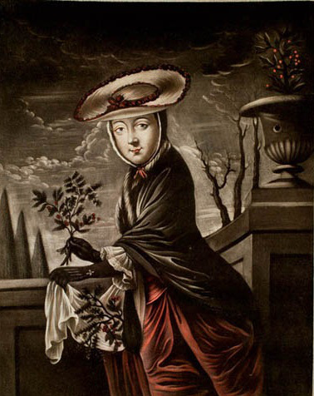

The Christmas season was a twelve day event during the colonial period. It would have started on December 25th (Christmas Day) and would end on January 6th. During this time, you would have great feasts and meal, attended parties, gone to visit others and would have received guests to your own home.

Christmas decorations were a common sight during the colonial period. However, those used today in Colonial Williamsburg are inaccurate recreation of the eighteenth century customs and materials.
Oranges, lemons and limes would never have been wasted on any form of decorations.
Pineapples were considered a precious commodity and you would have never seen them used.
What were used were garlands of holly, ivy, mountain laurel, berries, mistletoe or whatever natural materials were available.

Lavender, rose petals and pungent herbs like rosemary and bay set the holiday scent for the season. Also during the colonial period, only one or two rooms in the home would have been decorated. The church was general more decorated than the homes. The door would have had decoration, but no Christmas tree. Most Christmas trees didn’t make their debut until the nineteenth century.

Page 4
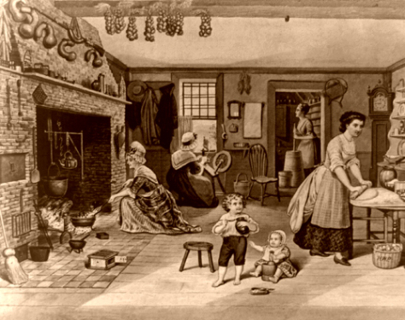
Christmas meals would have been fresh meats such as beef, goose, ham and turkey.
They would have also had fish, oysters, mincemeat pies and brandied peaches.
In the well to do households you would have found wines, brandy, rum punches and other alcoholic beverages.

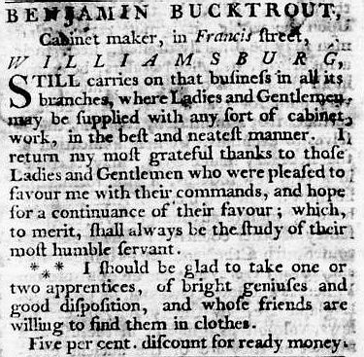
Page 5
Christmas gift giving during the colonial period was also a little different than what we know today. Believe it or not but eighteenth century shopkeepers placed printed ads noting items appropriate as holiday gifts. But there wasn’t a special day that it was given on. No real Christmas morning of unwrapping presents. Gift giving was done from masters or parents to dependents such as children, servants, apprentices and slaves. But the dependents didn’t return the gifts. This tradition didn’t come about until later and was a new American tradition. Santa Claus was also an American invention although European countries had their own version of him. In colonial times, Santa Claus or Father Christmas didn’t visit the children as he does today.

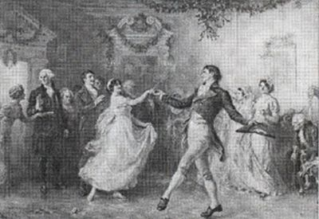

Christmas carols and hymns were very popular during the colonial period. During the Christmas season there would have been lots of dancing and singing at the many parties. Hymns were always sung, but beloved songs such as “Joy to the World”, “The First Noel” and “God Rest You Merry Gentlemen” were among the songs at parties. However no Christmas carols were ever sung at church.
Our present day customs have been derived from the many immigrants who settled this country with most of our traditions coming out of the nineteenth century. But this look back at the colonial period, when things were truly more simple I hope will give you a chance to really embrace the Christmas season and focus on the true meaning of the time.
Page 6

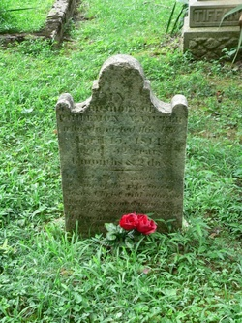
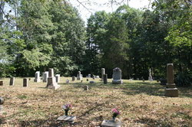
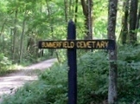
Philemon Vawter gravesite in Indiana. The cemetery is called Summerfield Cemetery. Philemon came from VA thru KY to IN. The cemetery is well kept and has many other Vawter family members

18th Century Thread & Covered Buttons
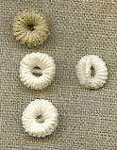
Thread buttons were used on the collars of men's shirts and other undergarments from the late 17th into the early 19th century. Not only were thread buttons less expensive than bone, wood or metal but they would not break during the strenuous beating and scrubbing used by the laundresses which is described in the book The Laundress. Unlike buttons made of other materials, thread buttons are soft and comfortable to lay against while sleeping.
Thread buttons (also called Dorset buttons after the area that produced many) are individually hand made from either unbleached (top), off white (center) or white (bottom) strong 16/2 linen thread and are approximately 1/2" in size. There is a small thread shank at the back to sew to your undergarment (right). In 1757 a criminal trial was recorded in The Proceedings of the Old Bailey, London in which a man "was indicted for stealing . . . twelve dozen of thread buttons for shirts" among other things.

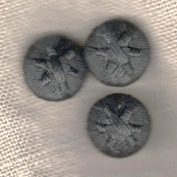
Throughout the 18th and early 19th centuries there were many types of thread buttons available. Star buttons were less common than death head or basket but are found on some original garments. Our 1/2 inch (13 mm) buttons are a perfect size for a man's waistcoat and are made of silk over a pasteboard button mold. It is best to cover buttons in foil before dry cleaning. In The Proceedings of the Old Bailey, London in 1789 a criminal was identified when the accuser said "This is the coat I saw the prisoner with; I am looking at the stars on the buttons, it was a new coat and very pretty buttons"Crosswheel buttons were used on underclothes and waistcoats from the 18th to early 19th century. These hand made of 35/2 white linen thread on solid brass rings and are about 1/2" across. These are very similar to the buttons on an extant c. 1770s white linen boy's wistcoat at the Connecticut Historical Society.

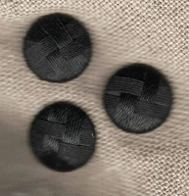
Throughout the 18th and early 19th centuries there were many types of thread buttons available. Star buttons were less common than death head or basket but are found on some original garments. Our 1/2 inch (13 mm) buttons are a perfect size for a man's waistcoat and are made of silk over a pasteboard button mold. It is best to cover buttons in foil before dry cleaning.

Page 8
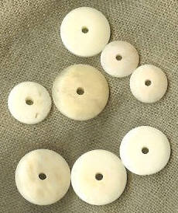
Bone button molds are slightly domed on one side and flat on the other
as were common in the mid to late 18th century. Button molds made of bone like this are found abundantly at 18th century cites across the United States, Canada and Europe. Many people feel these were the most common type of button found on civilian clothing throughout the 18th century. Fabric covered buttons may be made of either wood or bone but if the garment will be washed bone may hold up better. It is easiest to make "death head" buttons using wood button molds since the rough texture of the wood help hold the threads in place. Directions for cloth covered buttons are included in The Lady's Guide to Plain Sewing [Book II] and The Packet V. For example in New Jersey in 1780, there was "Stolen from a House - one light coloured watch-coat, buttons covered with the same coloured cloth".

Brown horn buttons have irregularities in the color based on the cow's horn they are stamped from and are only 1/8" thick. Horn buttons work well for spatterdashes and gaitered trousers but were sometimes used in other outer clothing. These strong durable buttons were competitive in price with other types but available in limited numbers in the 18th century since the making of them was slow. Being stamped or pressed out of horn these lack the center hole of the wood and bone molds. Rather these have two small holes. For example from personal communication with Mike Barbieri an ad in The Connecticut Courant of 1770, "RUN away . . . two Negro Men, one . . . carried with him one . . . velvet Waistcoat, snuff-colour’d horn Buttons, one other ditto, something worn".
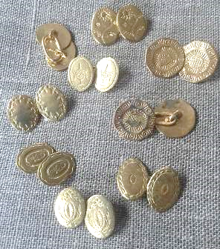
Sleeve buttons were used on the sleeves of men's shirts and women's shifts from the early 18th to the early 19th century. Cuff links are often confused with sleeve buttons but are structurally different. Sleeve buttons have been found in such numbers at archaeological sites from Ft. Michilimackinac, Michigan to Williamsburg, Virginia people of all economic standing wore sleeve buttons. In this 1754 painting Joseph Mann of Boston by John Singleton Copley wears what appear to be plain brass sleeve buttons. Sleeve buttons were issued to soldiers of many military regiments including the 17th of Foot in 1776 and the 42nd Royal Highland Regiment in 1778. For example in the 1754 Proceedings of the Old Bailey in London two women "were indicted, for that they, in a certain open court, near the king's highway, on Robert Newton did make an assault, putting him in corporal fear and danger of his life, and stealing from his person . . . one pair of brass sleeve buttons".

From top center going clockwise flower, hexagonal, hexagonal showing back and front, shield, ribbon, small flower, wreath, urn and reverse showing soldered brass attachment We sell these buttons by the set which includes enough buttons for one shift or shirt. In other words two pairs of buttons each pair connected by an attachment.

Page 9

2018 VVV FAMILY ASSOCIATION REUNION

After an absence of 36 years, the reunion of the VVV Family Association will once again be held in Madison, Indiana. The dates for the event are July 19-20-21, 2018. For some members, this will be a return visit, as several of those attending the 1982 reunion remain active in the association. For others, it will be their first time to visit the area where Jesse Vawter and his family settled in the very early 1800s in what was then called the New Purchase.

Located in Southern Indiana along the Ohio River, Madison quickly gained prominence
with the arrival of the steamboat and brisk river trade. The community prospered and beautiful buildings and homes were built along and near the river. Today the town
boasts the largest historic district in Indiana and the largest contiguous National Historic Landmark District in the United States. There are over 133 blocks on the National Register
of Historic Places.

During the reunion, we will also spend a day about 20 miles north of Madison in Jennings County visiting Vernon and North Vernon, stopping on the way there to view the grave of Jesse Vawter. Vernon was platted by John Vawter, a son of Jesse, about 1815. Indiana became a state in 1816, and land was given by John to the county commissioners for the county seat. He was a Baptist minister, and helped organize Vernon Baptist Church in April 1816. A few Vawter homes still exist in Vernon.

At North Vernon, we will go to the Vawter-Summerfield Cemetery, where many of us have ancestors buried. The cemetery is in Selmier State Forest, once the home of William and Frances Vawter, and is where they built a home overlooking the Muscatatuck River. The association last visited Jennings County in 1999.

A schedule of the plans and meal costs will be given in the March newsletter.

All members and friends are encouraged to attend the 2018 VVV reunion. It will be an opportunity to learn more about our Indiana ancestors and cousins.

We look forward to seeing everyone in Indiana!

Page 10

CLIFTY FALLS STATE PARK

As in 1982, we are staying at Clifty Falls State Park, where rooms have been booked at the Clifty Inn. The inn is located just off the south entrance of the park, and is about two miles from the historic district of Madison. A variety of rooms are booked for July 19 - 21. Because some people may want to arrive early, we have a few rooms for Wednesday, July 18. Applicable taxes will be added to all rates.

Parkside, One queen bed, ADA
July 19, $111.99; July 20, $134.99; July 21, $134.99

Parkside, Two queen beds
July 18, $111.99; July 19, $111.99; July 20, $134.99; July 21, $134.99

Riverview, Two queen beds
July 18, $121.99; July 19, $121.99; July 20, $149.99; July 21, $149.99

Riverview, Two queen beds, ADA
July 18, $121.99; July 19, $121.99; July 20, $149.99; July 21, $149.99

Riverview, Two queen beds, Balcony
July 19, $131.99; July 20, $159.99; July 21, $159.99

Riverview, Two queen beds, Patio
July 18, $131.99; July 19, $131.99; July 20, $159.99; July 21, $159.99

To make reservations, go online at www.Indianainns.com or call toll free 1-877-563-4371.
When making a reservation, don’t forget to give our code #0717VF.

Things you need to know:
If you make a reservation for a Parkside room and have a problem with stairs, be sure to request a ground floor room. There is no elevator in that section of the inn.

This is a popular state park, and the inn is usually sold out. The release date for our rooms is May 20, so reservations need to be made before then. We cannot guarantee the availability of rooms after that date. Cancellations can be made up to four days prior to the reservation. Check in time is 4:00 p.m., and check out is noon.

There is a fee of $9.00 per car for out-of-state vehicles, and $7.00 per car for in-state. This is a one time only fee, and you will not be required to pay each time you enter the park.

If you have questions, please contact Bonita Welch at bwelchbf@yahoo.com
or on Facebook at Bonita Taylor Welch. Page 11

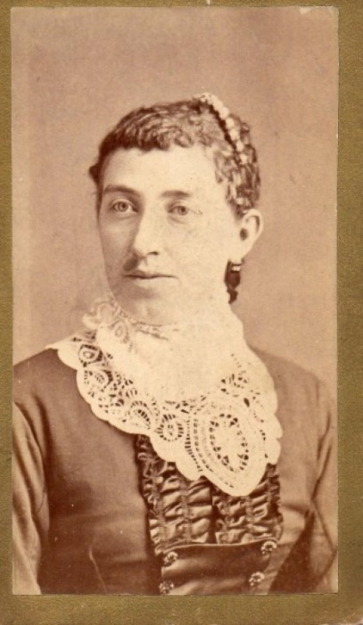
Sarah Alice Vawter (Nee: Campbell) | USA | 1851-1900 | Comments: On the back is written "Alice Campbell, Mrs C M Vawter". Sarah Alice Campbell was born July 29, 1859 in Indiana, and died some time in 1940. She married Charles Minton Vawter (grandson of Rev Col John Vawter, founder of Morgantown, Indiana) August 11, 1884.

This image and information was found on the website- deadfred.com . This site tries to find owners of pictures found or unknown. If you are a family member of this line you can go to the website to copy an image of this picture for your files.

Vawter Cemetery

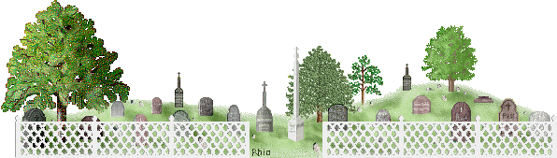
450N 1060W

Prairie Twp., Tipton Co., Indiana

James M. Vawter 1810-1872, b. North Carolina

par. John & Elizabeth Vawter

m. Irena Reed 30 May 1838 Jefferson Co., Indiana

Irena Reed 1819-1881
Posted online by Richard Kincaid. It is hard to write about a subject when one doesn’t know much about it. But anyway, here goes. Everything known today about the Vawter family cemetery is the result of the fine work of the D.A.R. done in 1978.
According to their research, ownership of the property surrounding the twelve by thirty foot cemetery left the Vawter family July, 1883 when it was transferred to Caswell and Emily Morrison. The cemetery, however, remained the property of Elizabeth (Vawter) Wright at that time. The cemetery is mentioned twice again in December, 1884 and August, 1894 title transfers. It was omitted in a February, 1896 and subsequent transfers. To make a long story short: nothing remains to mark this cemetery.
Relatives of the Vawter family interviewed by the D.A.R. remember four or five stones that disappeared after the possession of the land left the Vawter family So, who is buried here? All sources are in agreement that James M. Vawter and his wife Irena are interred here. It is plausible that their infant children/grandchildren are buried here. Possibly friends or nearby neighbors may be buried here also. The cemetery lies north of county road 450 N.

Page 12

